**EXPERIMENT NO.: 1A - CAESAR CIPHER**

**AIM:**

To write a C program to generate Caesar Cipher.

**ALGORITHM:**

**Step 1:**Start the program.

**Step 2:** Initialize the variable.

**Step 3:**Caesar cipher (shift cipher) is a simple substitution cipher based on areplacement of every single character of the open text with a character, which is fixednumber of positions further down the alphabet.

**Step 4:**The alphabet is shifted by an arbitrary number of positions. The number of positions is the key value. Shifting the bottom alphabet 3 position to the right yields the following result: A B C D E F G H I J K L M N O P Q R S T U V W X Y Z D E F G H I J K L M N O P Q R S T U V W X Y Z A B C

**Step 5:** The encryption can be described with the following formula: **Ci = (Ti + k) (mod m)** where, Ci – ith character of the closed text, Ti – ith character of the closed text, k – shift, m – length of the alphabet.

**Step 6:**The process of decryption uses reverted procedure: **Ti = (Ci – k) (mod m)**. The letter A becomes D, B is replaced by E, C is replaced by F, etc.

**Step 7:** Terminate the program.

**SOURCE CODE:**

**#include <stdio.h>**

**#include <ctype.h>**

**int main()**

**{**

**char str[100];**

**int key;**

**printf("Enter your message : ");**

**scanf("%s",str);**

**printf("Enter your key : ");**

**scanf("%d",&key);**

**for(int index=0;str[index]!='\0';index++)**

**{**

**char ch=str[index]-'a';**

**ch=(ch+key)%26;**

**str[index]=ch+'a';**

**}**

**printf("Cipher Text : %s",str);**

**return 0;**

**}**

**SAMPLE INPUT & OUTPUT:**

**Input:**

Enter your message : Melodious

Enter your key : 4

**Output:**

Cipher Text : Qipshmsyw

**OUTPUT SCREENSHOT:**

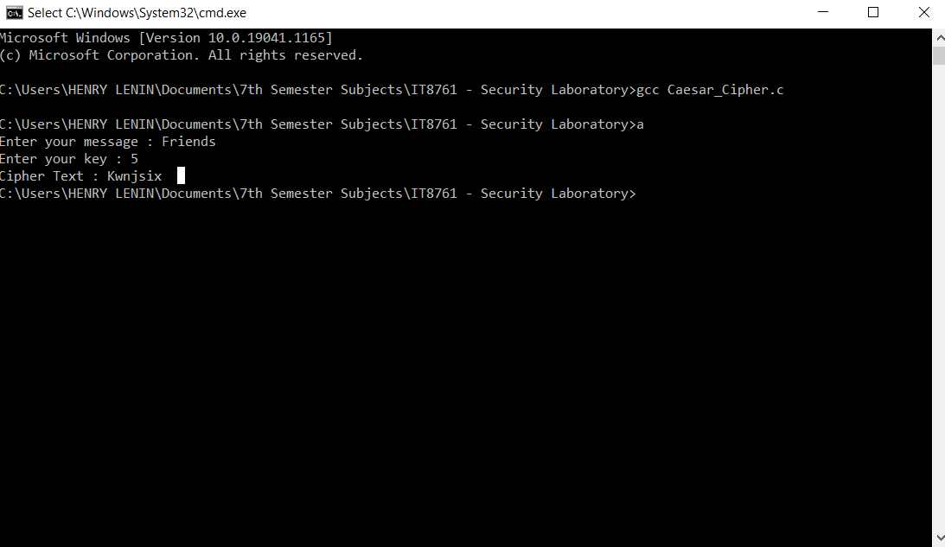

**RESULT:**

Thus, the program to implement Caesar Cipher is executed successfully.

**EXPERIMENT NO.: 1B - PLAYFAIR CIPHER**

**AIM:**

To write a C program to generate Playfair Cipher.

**ALGORITHM:**

**Step 1:** Start the program.

**Step 2:** Create a 5x5 matrix of letters based on a keyword.

**Step 3:** Fill in the letters of keyword.

**Step 4:** Fill rest of the matrix with other letters.

**Step 5:** Plaintext is encrypted 2 letters at a time.

* If a pair is a repeated letter , insert filler like ‘X’.
* If both letters fall in the same row, replace each with letter to right (wrapping back to start from end).
* If both letters fall in the same column, replace each with letter below it (wrapping back to top from bottom).
* Otherwise, each letter is replaced by letter in same row and column of other letter of the pair.

**Step 6:** Break the plaintext in a two-character diagram.

* Plaintext is divided into 2-letter diagram.
* Use X to separate double letter.
* Use X to pad the last single letter.

**Step 7:** Terminate the program.

**SOURCE CODE:**

**#include <stdio.h>**

**#include <string.h>**

**int main(void)**

**{**

**char matrix[5][5],key[10];**

**int i1,i2,j1,j2;**

**char temp[50],plain[50],cipher[50],ct_i=0;**

**printf("Enter the key word : ");**

**scanf("%s",key);**

**printf("Enter the plaintext : ");**

**scanf("%s",temp);**

**int i,j,k=0,count[26]={0};**

**for(i=0;i<5;i++)**

**{**

**for(j=0;j<5&&key[k]!='\0';j++)**

**{**

**if(key[k] == 'j')**

**{**

**k++;**

**continue;**

**}**

**matrix[i][j]=key[k];**

**count[key[k] - 'a']++;**

**k++;**

**}**

**if(key[k] == '\0')**

**break;**

**}**

**for(k=0;k<26;k++)**

**{**

**if(count[k] == 0 && ('a'+k)!='j')**

**{**

**matrix[i][j++] = ('a'+k);**

**}**

**if(j==5)**

**{**

**i++;**

**j=0;**

**}**

**}**

**int len = strlen(temp);**

**for(i=0,j=0;i<len;i++)**

**{**

**if(j==0 || temp[i] != plain[j-1])**

**plain[j++] = temp[i];**

**else**

**{**

**plain[j++] = 'x';**

**}**

**}**

**if(j%2 !=0)**

**{**

**plain[j++] = 'x';**

**}**

**plain[j] = '\0';**

**printf("Modified plaintext : %s\n",plain);**

**for(i=0;i<len-1;i+=2)**

**{**

**for(j=0;j<5;j++)**

**{**

**for(k=0;k<5;k++)**

**{**

**if(matrix[j][k] == plain[i] )**

**{**

**i1=j;**

**j1=k;**

**}**

**if(matrix[j][k] == plain[i+1])**

**{**

**i2=j;**

**j2=k;**

**}**

**}**

**}**

**if(i1 == i2)**

**{**

**cipher[ct_i++] = matrix[i1][(j1+1)%5];**

**cipher[ct_i++] = matrix[i2][(j2+1)%5];**

**}**

**else if(j1 == j2)**

**{**

**cipher[ct_i++] = matrix[(i1+1)%5][j1];**

**cipher[ct_i++] = matrix[(i2+1)%5][j2];**

**}**

**else**

**{**

**cipher[ct_i++] = matrix[i1][j2];**

**cipher[ct_i++] = matrix[i2][j1];**

**}**

**}**

**cipher[ct_i]='\0';**

**printf("Cipher text : %s",cipher);**

**return 0;**

**}**

**SAMPLE INPUT & OUTPUT:**

**Input:**

Enter the key word : game

Enter the plaintext : throne

**Output:**

Modified plaintext : throne

Cipher Text : yotlom

**OUTPUT SCREENSHOT:**

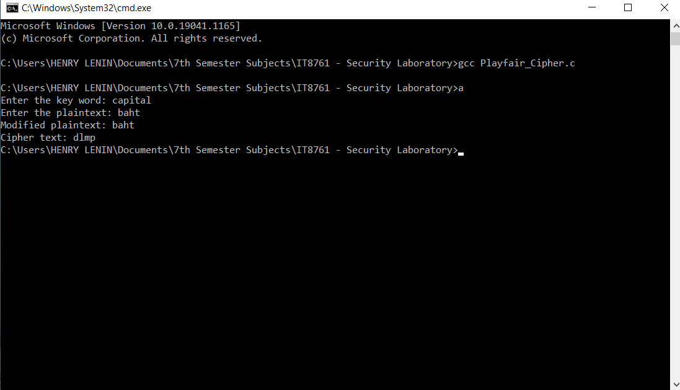

**RESULT:**

Thus, the program to implement Playfair Cipher is executed successfully.

**EXPERIMENT NO.: 1C - HILL CIPHER**

**AIM:**

To write a C++ program to generate Hill Cipher.

**ALGORITHM:**

**Step 1:**Start the program.

**Step 2:**The Hill cipher uses matrix multiplication to encrypt a message.

**Step 3:**First, we need to assign 2 numbers to each letter in the alphabet.

**Step 4:**Encryption. Use the table and 00 for spaces.

| **A** | **B** | **C** | **D** | **E** | **F** | **G** | **H** | **I** | **J** | **K** | **L** | **M** |
| --- | --- | --- | --- | --- | --- | --- | --- | --- | --- | --- | --- | --- |
| 1 | 2 | 3 | 4 | 5 | 6 | 7 | 8 | 9 | 10 | 11 | 12 | 13 |
| **N** | **O** | **P** | **Q** | **R** | **S** | **T** | **U** | **V** | **W** | **X** | **Y** | **Z** |
| 14 | 15 | 16 | 17 | 18 | 19 | 20 | 21 | 22 | 23 | 24 | 25 | 26 |

**Step 5:**Break the message and convert the message into number pairs

**Step 6:**Now, using the matrix key, make the first pair as a column vector and multiply that matrix by a key.

**Step 7:** Terminate the program.

**SOURCE CODE:**

**#include<iostream>**

**#include<vector>**

**using namespace std;**

**int main()**

**{**

**int x,y,i,j,k,n;**

**cout<<"Enter the size of key matrix : ";**

**cin>>n;**

**cout<<"Enter the key matrix\n";**

**int a[n][n];**

**for(i=0;i<n;i++){**

**for(j=0;j<n;j++){**

**cin>>a[i][j];**

**}**

**}**

**cout<<"Enter the message to encrypt : ";**

**string s;**

**cin>>s;**

**int temp = (n-s.size()%n)%n;**

**for(i=0;i<temp;i++){**

**s+='x';**

**}**

**k=0;**

**string ans="";**

**while(k<s.size()){**

**for(i=0;i<n;i++){**

**int sum = 0;**

**int temp = k;**

**for(j=0;j<n;j++){**

**sum += (a[i][j]%26*(s[temp++]-'a')%26)%26;**

**sum = sum%26;**

**}**

**ans+=(sum+'a');**

**}**

**k+=n;**

**}**

**cout<<"Cipher Text : "<<ans<<'\n';**

**return 0;**

**}**

**SAMPLE INPUT & OUTPUT:**

**Input:**

Enter the size of key matrix : 2

Enter the key matrix

6 9

5 8

Enter the message to encrypt : gift

**Output:**

Cipher Text : eqtv

**OUTPUT SCREENSHOT:**

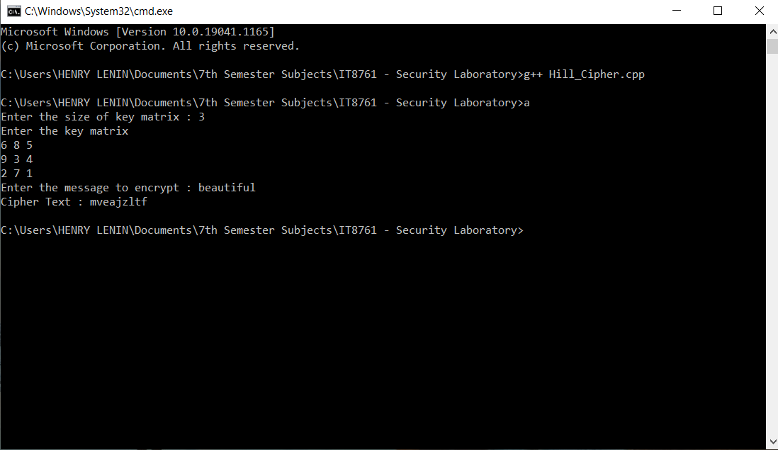

**RESULT:**

Thus, the program to implement Hill Cipher is executed successfully.

**EXPERIMENT NO.: 1D - VIGENERE CIPHER**

**AIM:**

To write a C program to generate Vigenère Cipher.

**ALGORITHM:**

**Step 1:**Start the program.

**Step 2:**Apply simplest polyalphabetic substitution cipher.

**Step 3:**Key is multiple letters along K = k1 k2 … kid. ith letter specifies ith alphabet to use.

**Step 4:**Use each alphabet in turn. Repeat from start after ‘n’ letters in message.

**Step 5:**Decryption simply works in reverse.

**Step 6:**Write the plaintext out and write keyword repeated above it. Use each key letter as a Caesar cipher key and encrypt the corresponding plaintext letter by using the math equation **C = E(p) = (p + ki) mod 26**.

**Step 7:** Terminate the program.

**SOURCE CODE:**

**#include <stdio.h>**

**int main(void)**

**{**

**char plain[100],cipher[100];**

**int key[100],len,i;**

**printf("Enter length of key : ");**

**scanf("%d",&len);**

**printf("Enter the key : ");**

**for(i=0;i<len;i++)**

**{**

**scanf("%d",&key[i]);**

**}**

**printf("Enter the plaintext : ");**

**scanf("%s",plain);**

**for(i=0;plain[i]!='\0';i++)**

**{**

**char c = plain[i]-'a';**

**cipher[i] = ((c+key[i%len])%26)+'A';**

**}**

**cipher[i]='\0';**

**printf("The cipher is %s",cipher);**

**return 0;**

**}**

**SAMPLE INPUT & OUTPUT:**

**Input:**

Enter length of key : 4

Enter the key : 9 5 7 3

Enter the plaintext : victory

**Output:**

The Cipher is ENJWXWF

**OUTPUT SCREENSHOT:**

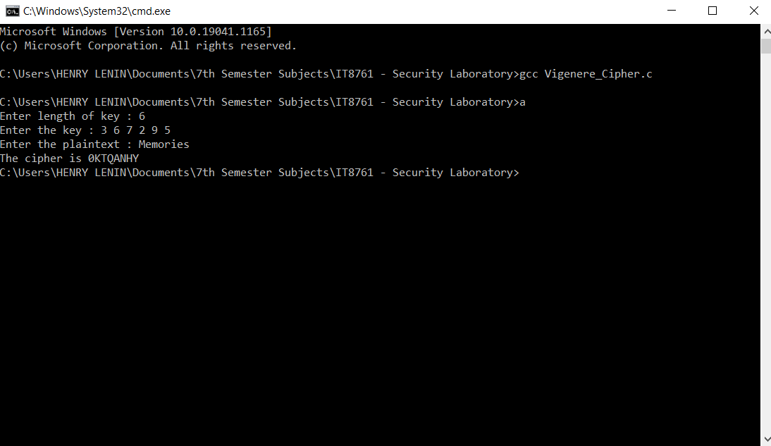

**RESULT:**

Thus, the program to implement Vigenère Cipher is executed successfully.

**EXPERIMENT NO.: 2A –RAIL FENCE CIPHER**

**AIM:**

To write a C program to generate Rail Fence Cipher.

**ALGORITHM:**

**Step 1:**Start the program.

**Step 2:**The key for the rail fence cipher is just the number of rails.

**Step 3:**Write message letters out diagonally over a few rows and then read off cipher row by row.

**Step 4:**We write it out in a special way on a few rails.

**Step 5:** The cipher text is then read off along the rows.

**Step 6:**With the key value the cipher text is again read off along the rows.

**Step 7:** Terminate the program.

**SOURCE CODE:**

**#include <stdio.h>**

**#include <string.h>**

**#include <stdlib.h>**

**#define VAL(PTR) (*PTR)**

**typedef char* STRING;**

**typedef char** STRING_REF;**

**void flush_stdin()**

**{**

**while(fgetc(stdin) != '\n');**

**}**

**void rail_fence_encrypt(STRING_REF str, int depth)**

**{**

**STRING old_str = VAL(str);**

**int len_str = strlen(old_str), itr_str, rows, cols;**

**STRING res_str = (STRING)malloc(sizeof(char)*len_str);**

**for(rows = 0, itr_str = 0 ; rows < depth ; ++rows)**

**{**

**for(cols = rows ; cols <len_str ; cols += depth)**

**{**

**res_str[itr_str] = old_str[cols];**

**++itr_str;**

**}**

**}**

**res_str[itr_str] = '\0';**

**free(VAL(str));**

**VAL(str) = res_str;**

**}**

**void rail_fence_decrypt(STRING_REF str, int depth)**

**{**

**STRING old_str = VAL(str);**

**int len_str = strlen(old_str), itr_str, rows, counter;**

**STRING res_str = (STRING)malloc(sizeof(char)*len_str);**

**for(counter = 0, itr_str = 0 ; counter <len_str/depth ; ++counter)**

**{**

**for(rows = counter ; rows <len_str ; rows+=(len_str/depth))**

**{**

**res_str[itr_str] = old_str[rows];**

**++itr_str;**

**}**

**}**

**free(VAL(str));**

**VAL(str) = res_str;**

**}**

**int main(void)**

**{**

**STRING str;**

**int txt_length, key;**

**printf("Enter the depth: ");**

**scanf("%d",&key);**

**printf("Enter the length of the text: ");**

**scanf("%d",&txt_length);**

**printf("Enter the message to be encrypted: ");**

**flush_stdin();**

**str = (char*)malloc((txt_length+1)*sizeof(char));**

**fgets(str,txt_length+1,stdin);**

**rail_fence_encrypt(&str,key);**

**printf("\nThe encrypted text is: %s",str);**

**rail_fence_decrypt(&str,key);**

**printf("\nThe decrypted text is: %s\n",str);**

**return 0;**

**}**

**SAMPLE INPUT & OUTPUT:**

**Input:**

Enter the depth : 2

Enter the length of the text : 10

Enter the message to be encrypted : attack now

**Output:**

The encrypted text is : atc otaknw

The decrypted text is : attack now

**OUTPUT SCREENSHOT:**

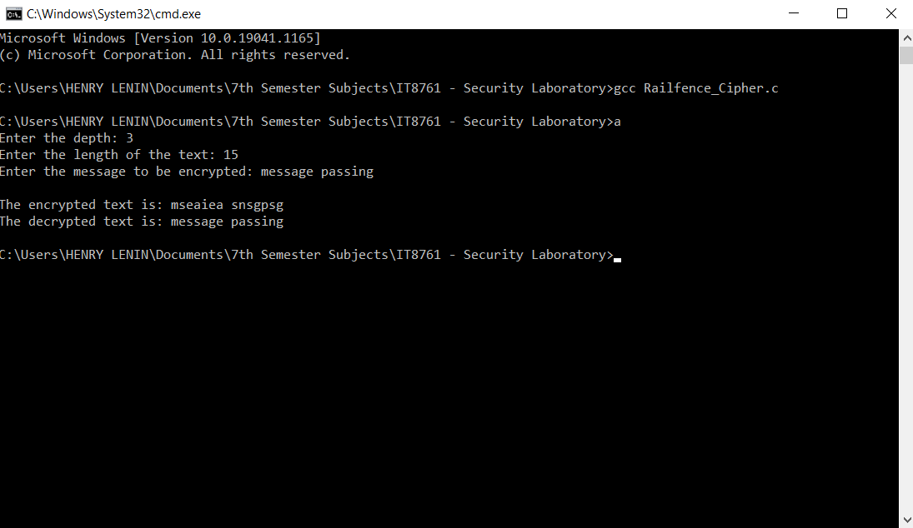

**RESULT:**

Thus, the program to implement Rail Fence Cipher is executed successfully.

**EXPERIMENT NO.: 2B–ROW AND COLUMN TRANSFORMATION TECHNIQUE**

**AIM:**

To implement a C++ program for encryption and decryption using Row and Column Transformation Technique.

**ALGORITHM:**

**Step 1:**Start the program.

**Step 2:**The message is written out in rows of a fixed length, and then read again column by column, and the columns are chosen in some scrambled order.

**Step 3:**The width of the rows and the permutation of the columns are usually defined by a keyword.

**Step 4:**Finally, the message is read off in columns, in the order specified by the keyword.

**Step 5:**To decipher it, the recipient must work out the column lengths by dividing the message length by the key length

**Step 6:**Then, write the message out in columns again, then re-order the columns by reforming the key word.

**Step 7:** Terminate the program.

**SOURCE CODE:**

**#include<bits/stdc++.h>**

**using namespace std;**

**string const key = "HACK";**

**map<int,int>keyMap;**

**void setPermutationOrder()**

**{**

**for(int i=0; i<key.length(); i++)**

**{**

**keyMap[key[i]] = i;**

**}**

**}**

**string encryptMessage(string msg)**

**{**

**int row,col,j;**

**string cipher = "";**

**col = key.length();**

**row = msg.length()/col;**

**if (msg.length() % col)**

**row += 1;**

**char matrix[row][col];**

**for (int i=0,k=0; i< row; i++)**

**{**

**for (int j=0; j<col; )**

**{**

**if(msg[k] == '\0')**

**{**

**matrix[i][j] = '_';**

**j++;**

**}**

**if( isalpha(msg[k]) || msg[k]==' ')**

**{**

**matrix[i][j] = msg[k];**

**j++;**

**}**

**k++;**

**}**

**}**

**for (map<int,int>::iterator ii = keyMap.begin(); ii!=keyMap.end(); ++ii)**

**{**

**j=ii->second;**

**for (int i=0; i<row; i++)**

**{**

**if( isalpha(matrix[i][j]) || matrix[i][j]==' ' || matrix[i][j]=='_')**

**cipher += matrix[i][j];**

**}**

**}**

**return cipher;**

**}**

**string decryptMessage(string cipher)**

**{**

**int col = key.length();**

**int row = cipher.length()/col;**

**char cipherMat[row][col];**

**for (int j=0,k=0; j<col; j++)**

**for (int i=0; i<row; i++)**

**cipherMat[i][j] = cipher[k++];**

**int index = 0;**

**for( map<int,int>::iterator ii=keyMap.begin(); ii!=keyMap.end(); ++ii)**

**ii->second = index++;**

**char decCipher[row][col];**

**map<int,int>::iterator ii=keyMap.begin();**

**int k = 0;**

**for (int l=0,j; key[l]!='\0'; k++)**

**{**

**j = keyMap[key[l++]];**

**for (int i=0; i<row; i++)**

**{**

**decCipher[i][k]=cipherMat[i][j];**

**}**

**}**

**string msg = "";**

**for (int i=0; i<row; i++)**

**{**

**for(int j=0; j<col; j++)**

**{**

**if(decCipher[i][j] != '_')**

**msg += decCipher[i][j];**

**}**

**}**

**return msg;**

**}**

**int main(void)**

**{**

**/* message */**

**string msg;**

**cout<< "Enter your Message : ";**

**getline(cin, msg);**

**setPermutationOrder();**

**string cipher = encryptMessage(msg);**

**cout<< "Encrypted Message: " << cipher <<endl;**

**cout<< "Decrypted Message: " <<decryptMessage(cipher) <<endl;**

**return 0;**

**}**

**SAMPLE INPUT & OUTPUT:**

**Input:**

Enter your message : Pass the message

**Output:**

Encrypted Message : atmashegP ssese

Decrypted Message : Pass the message

**OUTPUT SCREENSHOT:**

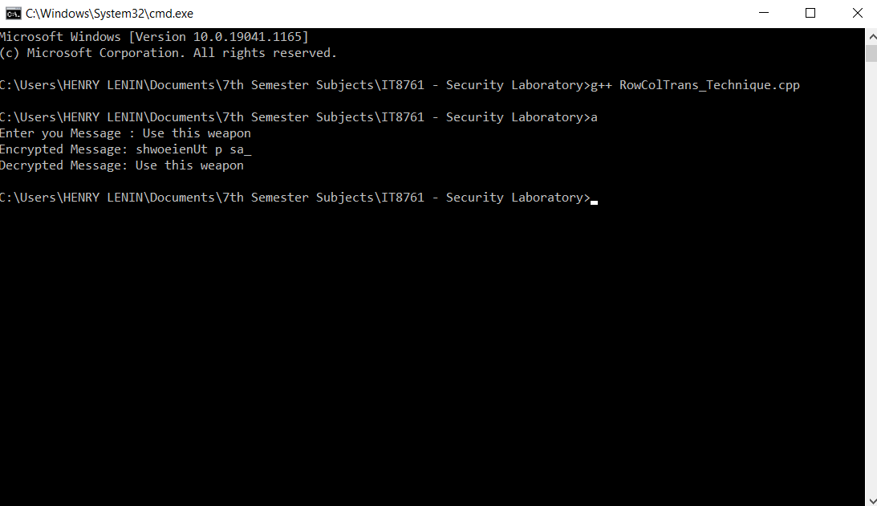

**RESULT:**

Thus, the program to implement Encryption and Decryption using Row and Column Transformation Technique is executed successfully.

**EXPERIMENT NO.: 3 - APPLICATIONS OF DES**

**SIMPLIFIED DES**

**AIM:**

To analyse the applications of DES algorithm and to apply DES algorithm to implement Simplified DES using a JAVA program.

**ALGORITHM:**

**Step 1:**Start the program.

**Step 2:**We perform initial permutation on our 8-bit plain text using the IP table.

**Step 3:**After the initial permutation, we get an 8-bit block of text which we divide into 2 halves of 4 bit each.

**Step 4:**Now, divide the output into two halves of 4 bit each. Combine them again, but now the left part should become right, and the right part should become left.

**Step 5:**Again, perform Step 3, but this time while doing XOR operation after expanded permutation use key 2 instead of key 1.

**Step 6:**Perform inverse initial permutation. The output of this table is the cipher text of 8 bit.

**Step 7:** Terminate the program.

**SOURCE CODE:**

**import java.io.*;**

**public class SimplifiedDES {**

**int key[] = {1, 0, 1, 0, 0, 0, 0, 0, 1, 0};**

**int P10[] = { 3, 5, 2, 7, 4, 10, 1, 9, 8, 6 };**

**int P8[] = { 6, 3, 7, 4, 8, 5, 10, 9 };**

**int key1[] = new int[8];**

**int key2[] = new int[8];**

**int[] IP = { 2, 6, 3, 1, 4, 8, 5, 7 };**

**int[] EP = { 4, 1, 2, 3, 2, 3, 4, 1 };**

**int[] P4 = { 2, 4, 3, 1 };**

**int[] IP_inv = { 4, 1, 3, 5, 7, 2, 8, 6 };**

**int[][] S0 = { { 1, 0, 3, 2 },**

**{ 3, 2, 1, 0 },**

**{ 0, 2, 1, 3 },**

**{ 3, 1, 3, 2 } };**

**int[][] S1 = { { 0, 1, 2, 3 },**

**{ 2, 0, 1, 3 },**

**{ 3, 0, 1, 0 },**

**{ 2, 1, 0, 3 } };**

**void key_generation()**

**{**

**int key_[] = new int[10];**

**for (int i = 0; i< 10; i++) {**

**key_[i] = key[P10[i] - 1];**

**}**

**int Ls[] = new int[5];**

**int Rs[] = new int[5];**

**for (int i = 0; i< 5; i++) {**

**Ls[i] = key_[i];**

**Rs[i] = key_[i + 5];**

**}**

**int[] Ls_1 = shift(Ls, 1);**

**int[] Rs_1 = shift(Rs, 1);**

**for (int i = 0; i< 5; i++) {**

**key_[i] = Ls_1[i];**

**key_[i + 5] = Rs_1[i];**

**}**

**for (int i = 0; i< 8; i++) {**

**key1[i] = key_[P8[i] - 1];**

**}**

**int[] Ls_2 = shift(Ls, 2);**

**int[] Rs_2 = shift(Rs, 2);**

**for (int i = 0; i< 5; i++) {**

**key_[i] = Ls_2[i];**

**key_[i + 5] = Rs_2[i];**

**}**

**for (int i = 0; i< 8; i++) {**

**key2[i] = key_[P8[i] - 1];**

**}**

**System.out.println("Your Key-1 :");**

**for (int i = 0; i< 8; i++)**

**System.out.print(key1[i] + " ");**

**System.out.println();**

**System.out.println("Your Key-2 :");**

**for (int i = 0; i< 8; i++)**

**System.out.print(key2[i] + " ");**

**}**

**int[] shift(int[] ar, int n)**

**{**

**while (n > 0) {**

**int temp = ar[0];**

**for (int i = 0; i<ar.length - 1; i++) {**

**ar[i] = ar[i + 1];**

**}**

**ar[ar.length - 1] = temp;**

**n--;**

**}**

**return ar;**

**}**

**int[] encryption(int[] plaintext)**

**{**

**int[] arr = new int[8];**

**for (int i = 0; i< 8; i++) {**

**arr[i] = plaintext[IP[i] - 1];**

**}**

**int[] arr1 = function_(arr, key1);**

**int[] after_swap = swap(arr1, arr1.length / 2);**

**int[] arr2 = function_(after_swap, key2);**

**int[] ciphertext = new int[8];**

**for (int i = 0; i< 8; i++) {**

**ciphertext[i] = arr2[IP_inv[i] - 1];**

**}**

**return ciphertext;**

**}**

**String binary_(int val)**

**{**

**if (val == 0)**

**return "00";**

**else if (val == 1)**

**return "01";**

**else if (val == 2)**

**return "10";**

**else**

**return "11";**

**}**

**int[] function_(int[] ar, int[] key_)**

**{**

**int[] l = new int[4];**

**int[] r = new int[4];**

**for (int i = 0; i< 4; i++) {**

**l[i] = ar[i];**

**r[i] = ar[i + 4];**

**}**

**int[] ep = new int[8];**

**for (int i = 0; i< 8; i++) {**

**ep[i] = r[EP[i] - 1];**

**}**

**for (int i = 0; i< 8; i++) {**

**ar[i] = key_[i] ^ ep[i];**

**}**

**int[] l_1 = new int[4];**

**int[] r_1 = new int[4];**

**for (int i = 0; i< 4; i++) {**

**l_1[i] = ar[i];**

**r_1[i] = ar[i + 4];**

**}**

**int row, col, val;**

**row = Integer.parseInt("" + l_1[0] + l_1[3], 2);**

**col = Integer.parseInt("" + l_1[1] + l_1[2], 2);**

**val = S0[row][col];**

**String str_l = binary_(val);**

**row = Integer.parseInt("" + r_1[0] + r_1[3], 2);**

**col = Integer.parseInt("" + r_1[1] + r_1[2], 2);**

**val = S1[row][col];**

**String str_r = binary_(val);**

**int[] r_ = new int[4];**

**for (int i = 0; i< 2; i++) {**

**char c1 = str_l.charAt(i);**

**char c2 = str_r.charAt(i);**

**r_[i] = Character.getNumericValue(c1);**

**r_[i + 2] = Character.getNumericValue(c2);**

**}**

**int[] r_p4 = new int[4];**

**for (int i = 0; i< 4; i++) {**

**r_p4[i] = r_[P4[i] - 1];**

**}**

**for (int i = 0; i< 4; i++) {**

**l[i] = l[i] ^ r_p4[i];**

**}**

**int[] output = new int[8];**

**for (int i = 0; i< 4; i++) {**

**output[i] = l[i];**

**output[i + 4] = r[i];**

**}**

**return output;**

**}**

**int[] swap(int[] array, int n)**

**{**

**int[] l = new int[n];**

**int[] r = new int[n];**

**for (int i = 0; i< n; i++) {**

**l[i] = array[i];**

**r[i] = array[i + n];**

**}**

**int[] output = new int[2 * n];**

**for (int i = 0; i< n; i++) {**

**output[i] = r[i];**

**output[i + n] = l[i];**

**}**

**return output;**

**}**

**int[] decryption(int[] ar)**

**{**

**int[] arr = new int[8];**

**for (int i = 0; i< 8; i++) {**

**arr[i] = ar[IP[i] - 1];**

**}**

**int[] arr1 = function_(arr, key2);**

**int[] after_swap = swap(arr1, arr1.length / 2);**

**int[] arr2 = function_(after_swap, key1);**

**int[] decrypted = new int[8];**

**for (int i = 0; i< 8; i++) {**

**decrypted[i] = arr2[IP_inv[i] - 1];**

**}**

**return decrypted;**

**}**

**public static void main(String[] args)**

**{**

**SimplifiedDESobj = new SimplifiedDES();**

**obj.key_generation();**

**int[] plaintext = {, 0, 0, 1, 0, 1, 1, 1};**

**System.out.println();**

**System.out.println("Your plain Text is :");**

**for (int i = 0; i< 8; i++)**

**System.out.print(plaintext[i] + " ");**

**int[] ciphertext = obj.encryption(plaintext);**

**System.out.println();**

**System.out.println("Your cipher Text is :");**

**for (int i = 0; i< 8; i++)**

**System.out.print(ciphertext[i] + " ");**

**int[] decrypted = obj.decryption(ciphertext);**

**System.out.println();**

**System.out.println(**

**"Your decrypted Text is :");**

**for (int i = 0; i< 8; i++)**

**System.out.print(decrypted[i] + " ");**

**}**

**}**

**SAMPLE INPUT & OUTPUT:**

**Input:**

Your Key – 1 : 1 0 1 0 0 1 0 0

Your Key – 2 : 0 1 0 0 0 0 1 1

Your plain Text is : 1 0 0 1 0 1 1 1

**Output:**

Your cipher Text is : 0 0 1 1 1 0 0 0

Your decrypted Text is : 1 0 0 1 0 1 1 1

**OUTPUT SCREENSHOT:**

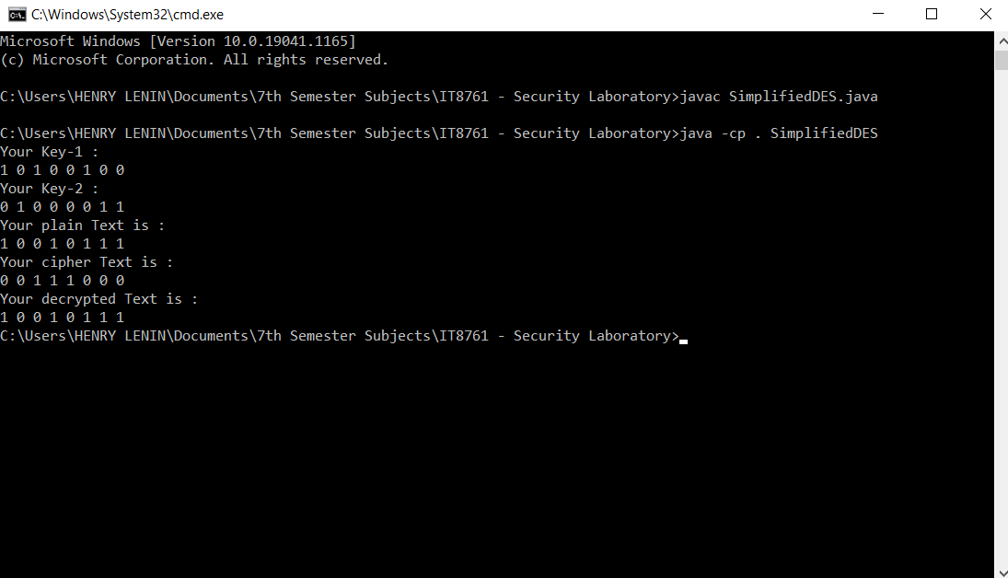

**RESULT:**

Thus, the program to implement Simplified DES is executed successfully.

**STANDARD DES**

**AIM:**

To analyse the applications of DES algorithm and to apply DES algorithm to implement Standard DES using a C++ program.

**ALGORITHM:**

**Step 1:** Start the program.

**Step 2:**In the first step, the 64-bit plain text is handed over to an initial permutation function.

**Step 3:**The initial permutation performed on plain text.

**Step 4:**Next the initial permutation produces two halves of the permuted block saying left plain text and right plain text.

**Step 5:**Now each left plain text and right plain text go through 16 rounds of encryption process.

**Step 6:**In the end, left plain text and right plain text are re-joined and a final permutation is performed on the combined block.

**Step 7:** The result of this process produces 64-bit cipher text.

**Step 8:** Terminate the program.

**SOURCE CODE:**

**#include <bits/stdc++.h>**

**using namespace std;**

**string hex2bin(string s)**

**{**

**unordered_map<char, string>mp;**

**mp['0'] = "0000";**

**mp['1'] = "0001";**

**mp['2'] = "0010";**

**mp['3'] = "0011";**

**mp['4'] = "0100";**

**mp['5'] = "0101";**

**mp['6'] = "0110";**

**mp['7'] = "0111";**

**mp['8'] = "1000";**

**mp['9'] = "1001";**

**mp['A'] = "1010";**

**mp['B'] = "1011";**

**mp['C'] = "1100";**

**mp['D'] = "1101";**

**mp['E'] = "1110";**

**mp['F'] = "1111";**

**string bin = "";**

**for (int i = 0; i<s.size(); i++) {**

**bin += mp[s[i]];**

**}**

**return bin;**

**}**

**string bin2hex(string s)**

**{**

**unordered_map<string, string>mp;**

**mp["0000"] = "0";**

**mp["0001"] = "1";**

**mp["0010"] = "2";**

**mp["0011"] = "3";**

**mp["0100"] = "4";**

**mp["0101"] = "5";**

**mp["0110"] = "6";**

**mp["0111"] = "7";**

**mp["1000"] = "8";**

**mp["1001"] = "9";**

**mp["1010"] = "A";**

**mp["1011"] = "B";**

**mp["1100"] = "C";**

**mp["1101"] = "D";**

**mp["1110"] = "E";**

**mp["1111"] = "F";**

**string hex = "";**

**for (int i = 0; i<s.length(); i += 4) {**

**string ch = "";**

**ch += s[i];**

**ch += s[i + 1];**

**ch += s[i + 2];**

**ch += s[i + 3];**

**hex += mp[ch];**

**}**

**return hex;**

**}**

**string permute(string k, int* arr, int n)**

**{**

**string per = "";**

**for (int i = 0; i< n; i++) {**

**per += k[arr[i] - 1];**

**}**

**return per;**

**}**

**string shift_left(string k, int shifts)**

**{**

**string s = "";**

**for (int i = 0; i< shifts; i++) {**

**for (int j = 1; j < 28; j++) {**

**s += k[j];**

**}**

**s += k[0];**

**k = s;**

**s = "";**

**}**

**return k;**

**}**

**string xor_(string a, string b)**

**{**

**string ans = "";**

**for (int i = 0; i<a.size(); i++) {**

**if (a[i] == b[i]) {**

**ans += "0";**

**}**

**else {**

**ans += "1";**

**}**

**}**

**return ans;**

**}**

**string encrypt(string pt, vector<string>rkb, vector<string>rk)**

**{**

**pt = hex2bin(pt);**

**int initial_perm[64] = { 58, 50, 42, 34, 26, 18, 10, 2,**

**60, 52, 44, 36, 28, 20, 12, 4,**

**62, 54, 46, 38, 30, 22, 14, 6,**

**64, 56, 48, 40, 32, 24, 16, 8,**

**57, 49, 41, 33, 25, 17, 9, 1,**

**59, 51, 43, 35, 27, 19, 11, 3,**

**61, 53, 45, 37, 29, 21, 13, 5,**

**63, 55, 47, 39, 31, 23, 15, 7 };**

**pt = permute(pt, initial_perm, 64);**

**cout<< "After initial permutation: " << bin2hex(pt) <<endl;**

**string left = pt.substr(0, 32);**

**string right = pt.substr(32, 32);**

**cout<< "After splitting: L0=" << bin2hex(left)**

**<< " R0=" << bin2hex(right) <<endl;**

**int exp_d[48] = { 32, 1, 2, 3, 4, 5, 4, 5,**

**6, 7, 8, 9, 8, 9, 10, 11,**

**12, 13, 12, 13, 14, 15, 16, 17,**

**16, 17, 18, 19, 20, 21, 20, 21,**

**22, 23, 24, 25, 24, 25, 26, 27,**

**28, 29, 28, 29, 30, 31, 32, 1 };**

**int s[8][4][16] = { { 14, 4, 13, 1, 2, 15, 11, 8, 3, 10, 6, 12, 5, 9, 0, 7,**

**0, 15, 7, 4, 14, 2, 13, 1, 10, 6, 12, 11, 9, 5, 3, 8,**

**4, 1, 14, 8, 13, 6, 2, 11, 15, 12, 9, 7, 3, 10, 5, 0,**

**15, 12, 8, 2, 4, 9, 1, 7, 5, 11, 3, 14, 10, 0, 6, 13 },**

**{ 15, 1, 8, 14, 6, 11, 3, 4, 9, 7, 2, 13, 12, 0, 5, 10,**

**3, 13, 4, 7, 15, 2, 8, 14, 12, 0, 1, 10, 6, 9, 11, 5,**

**0, 14, 7, 11, 10, 4, 13, 1, 5, 8, 12, 6, 9, 3, 2, 15,**

**13, 8, 10, 1, 3, 15, 4, 2, 11, 6, 7, 12, 0, 5, 14, 9 },**

**{ 10, 0, 9, 14, 6, 3, 15, 5, 1, 13, 12, 7, 11, 4, 2, 8,**

**13, 7, 0, 9, 3, 4, 6, 10, 2, 8, 5, 14, 12, 11, 15, 1,**

**13, 6, 4, 9, 8, 15, 3, 0, 11, 1, 2, 12, 5, 10, 14, 7,**

**1, 10, 13, 0, 6, 9, 8, 7, 4, 15, 14, 3, 11, 5, 2, 12 },**

**{ 7, 13, 14, 3, 0, 6, 9, 10, 1, 2, 8, 5, 11, 12, 4, 15,**

**13, 8, 11, 5, 6, 15, 0, 3, 4, 7, 2, 12, 1, 10, 14, 9,**

**10, 6, 9, 0, 12, 11, 7, 13, 15, 1, 3, 14, 5, 2, 8, 4,**

**3, 15, 0, 6, 10, 1, 13, 8, 9, 4, 5, 11, 12, 7, 2, 14 },**

**{ 2, 12, 4, 1, 7, 10, 11, 6, 8, 5, 3, 15, 13, 0, 14, 9,**

**14, 11, 2, 12, 4, 7, 13, 1, 5, 0, 15, 10, 3, 9, 8, 6,**

**4, 2, 1, 11, 10, 13, 7, 8, 15, 9, 12, 5, 6, 3, 0, 14,**

**11, 8, 12, 7, 1, 14, 2, 13, 6, 15, 0, 9, 10, 4, 5, 3 },**

**{ 12, 1, 10, 15, 9, 2, 6, 8, 0, 13, 3, 4, 14, 7, 5, 11,**

**10, 15, 4, 2, 7, 12, 9, 5, 6, 1, 13, 14, 0, 11, 3, 8,**

**9, 14, 15, 5, 2, 8, 12, 3, 7, 0, 4, 10, 1, 13, 11, 6,**

**4, 3, 2, 12, 9, 5, 15, 10, 11, 14, 1, 7, 6, 0, 8, 13 },**

**{ 4, 11, 2, 14, 15, 0, 8, 13, 3, 12, 9, 7, 5, 10, 6, 1,**

**13, 0, 11, 7, 4, 9, 1, 10, 14, 3, 5, 12, 2, 15, 8, 6,**

**1, 4, 11, 13, 12, 3, 7, 14, 10, 15, 6, 8, 0, 5, 9, 2,**

**6, 11, 13, 8, 1, 4, 10, 7, 9, 5, 0, 15, 14, 2, 3, 12 },**

**{ 13, 2, 8, 4, 6, 15, 11, 1, 10, 9, 3, 14, 5, 0, 12, 7,**

**1, 15, 13, 8, 10, 3, 7, 4, 12, 5, 6, 11, 0, 14, 9, 2,**

**7, 11, 4, 1, 9, 12, 14, 2, 0, 6, 10, 13, 15, 3, 5, 8,**

**2, 1, 14, 7, 4, 10, 8, 13, 15, 12, 9, 0, 3, 5, 6, 11 } };**

**int per[32] = { 16, 7, 20, 21,**

**29, 12, 28, 17,**

**1, 15, 23, 26,**

**5, 18, 31, 10,**

**2, 8, 24, 14,**

**32, 27, 3, 9,**

**19, 13, 30, 6,**

**22, 11, 4, 25 };**

**cout<<endl;**

**for (int i = 0; i< 16; i++) {**

**string right_expanded = permute(right, exp_d, 48);**

**string x = xor_(rkb[i], right_expanded);**

**string op = "";**

**for (int i = 0; i< 8; i++) {**

**int row = 2 * int(x[i * 6] - '0') + int(x[i * 6 + 5] - '0');**

**int col = 8 * int(x[i * 6 + 1] - '0') + 4 * int(x[i * 6 + 2] - '0') + 2 * int(x[i * 6 + 3] - '0') + int(x[i * 6 + 4] - '0');**

**int val = s[i][row][col];**

**op += char(val / 8 + '0');**

**val = val % 8;**

**op += char(val / 4 + '0');**

**val = val % 4;**

**op += char(val / 2 + '0');**

**val = val % 2;**

**op += char(val + '0');**

**}**

**op = permute(op, per, 32);**

**x = xor_(op, left);**

**left = x;**

**if (i != 15) {**

**swap(left, right);**

**}**

**cout<< "Round " <<i + 1 << " " << bin2hex(left) << " "**

**<< bin2hex(right) << " " <<rk[i] <<endl;**

**}**

**string combine = left + right;**

**int final_perm[64] = { 40, 8, 48, 16, 56, 24, 64, 32,**

**39, 7, 47, 15, 55, 23, 63, 31,**

**38, 6, 46, 14, 54, 22, 62, 30,**

**37, 5, 45, 13, 53, 21, 61, 29,**

**36, 4, 44, 12, 52, 20, 60, 28,**

**35, 3, 43, 11, 51, 19, 59, 27,**

**34, 2, 42, 10, 50, 18, 58, 26,**

**33, 1, 41, 9, 49, 17, 57, 25 };**

**string cipher = bin2hex(permute(combine, final_perm, 64));**

**return cipher;**

**}**

**int main()**

**{**

**string pt, key;**

**cout<<"Enter plain text(in hexadecimal): ";**

**cin>>pt;**

**cout<<"Enter key(in hexadecimal): ";**

**cin>>key;**

**key = hex2bin(key);**

**int keyp[56] = { 57, 49, 41, 33, 25, 17, 9,**

**1, 58, 50, 42, 34, 26, 18,**

**10, 2, 59, 51, 43, 35, 27,**

**19, 11, 3, 60, 52, 44, 36,**

**63, 55, 47, 39, 31, 23, 15,**

**7, 62, 54, 46, 38, 30, 22,**

**14, 6, 61, 53, 45, 37, 29,**

**21, 13, 5, 28, 20, 12, 4 };**

**key = permute(key, keyp, 56);**

**int shift_table[16] = { 1, 1, 2, 2,**

**2, 2, 2, 2,**

**1, 2, 2, 2,**

**2, 2, 2, 1 };**

**int key_comp[48] = { 14, 17, 11, 24, 1, 5,**

**3, 28, 15, 6, 21, 10,**

**23, 19, 12, 4, 26, 8,**

**16, 7, 27, 20, 13, 2,**

**41, 52, 31, 37, 47, 55,**

**30, 40, 51, 45, 33, 48,**

**44, 49, 39, 56, 34, 53,**

**46, 42, 50, 36, 29, 32 };**

**string left = key.substr(0, 28);**

**string right = key.substr(28, 28);**

**vector<string>rkb;**

**vector<string>rk;**

**for (int i = 0; i< 16; i++) {**

**left = shift_left(left, shift_table[i]);**

**right = shift_left(right, shift_table[i]);**

**string combine = left + right;**

**string RoundKey = permute(combine, key_comp, 48);**

**rkb.push_back(RoundKey);**

**rk.push_back(bin2hex(RoundKey));**

**}**

**cout<< "\nEncryption:\n\n";**

**string cipher = encrypt(pt, rkb, rk);**

**cout<< "\nCipher Text: " << cipher <<endl;**

**cout<< "\nDecryption\n\n";**

**reverse(rkb.begin(), rkb.end());**

**reverse(rk.begin(), rk.end());**

**string text = encrypt(cipher, rkb, rk);**

**cout<< "\nPlain Text: " << text <<endl;**

**}**

**SAMPLE INPUT & OUTPUT:**

**Input:**

Enter plain text(int hexadecimal) : 123456ABCD132536

Enter key(int hexadecimal : AABB09182736CCDD

**Output:**

Encryption:

After initial permutation: 14A7D67818CA18AD

After splitting: L0=14A7D678 R0=18CA18AD

Round 1 18CA18AD 5A78E394 194CD072DE8C

Round 2 5A78E394 4A1210F6 4568581ABCCE

Round 3 4A1210F6 B8089591 06EDA4ACF5B5

Round 4 B8089591 236779C2 DA2D032B6EE3

Round 5 236779C2 A15A4B87 69A629FEC913

Round 6 A15A4B87 2E8F9C65 C1948E87475E

Round 7 2E8F9C65 A9FC20A3 708AD2DDB3C0

Round 8 A9FC20A3 308BEE97 34F822F0C66D

Round 9 308BEE97 10AF9D37 84BB4473DCCC

Round 10 10AF9D37 6CA6CB20 02765708B5BF

Round 11 6CA6CB20 FF3C485F 6D5560AF7CA5

Round 12 FF3C485F 22A5963B C2C1E96A4BF3

Round 13 22A5963B 387CCDAA 99C31397C91F

Round 14 387CCDAA BD2DD2AB 251B8BC717D0

Round 15 BD2DD2AB CF26B472 3330C5D9A36D

Round 16 19BA9212 CF26B472 181C5D75C66D

Cipher Text: C0B7A8D05F3A829C

Decryption:

After initial permutation: 19BA9212CF26B472

After splitting: L0=19BA9212 R0=CF26B472

Round 1 CF26B472 BD2DD2AB 181C5D75C66D

Round 2 BD2DD2AB 387CCDAA 3330C5D9A36D

Round 3 387CCDAA 22A5963B 251B8BC717D0

Round 4 22A5963B FF3C485F 99C31397C91F

Round 5 FF3C485F 6CA6CB20 C2C1E96A4BF3

Round 6 6CA6CB20 10AF9D37 6D5560AF7CA5

Round 7 10AF9D37 308BEE97 02765708B5BF

Round 8 308BEE97 A9FC20A3 84BB4473DCCC

Round 9 A9FC20A3 2E8F9C65 34F822F0C66D

Round 10 2E8F9C65 A15A4B87 708AD2DDB3C0

Round 11 A15A4B87 236779C2 C1948E87475E

Round 12 236779C2 B8089591 69A629FEC913

Round 13 B8089591 4A1210F6 DA2D032B6EE3

Round 14 4A1210F6 5A78E394 06EDA4ACF5B5

Round 15 5A78E394 18CA18AD 4568581ABCCE

Round 16 14A7D678 18CA18AD 194CD072DE8C

Plain Text: 123456ABCD132536

**OUTPUT SCREENSHOTS:**

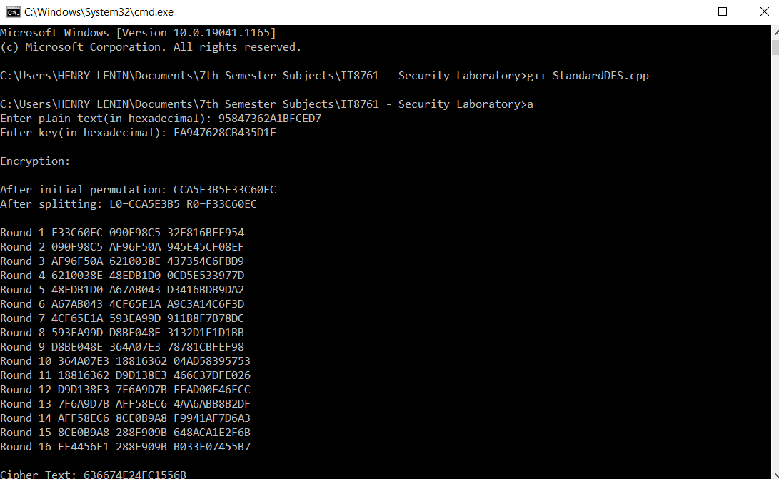

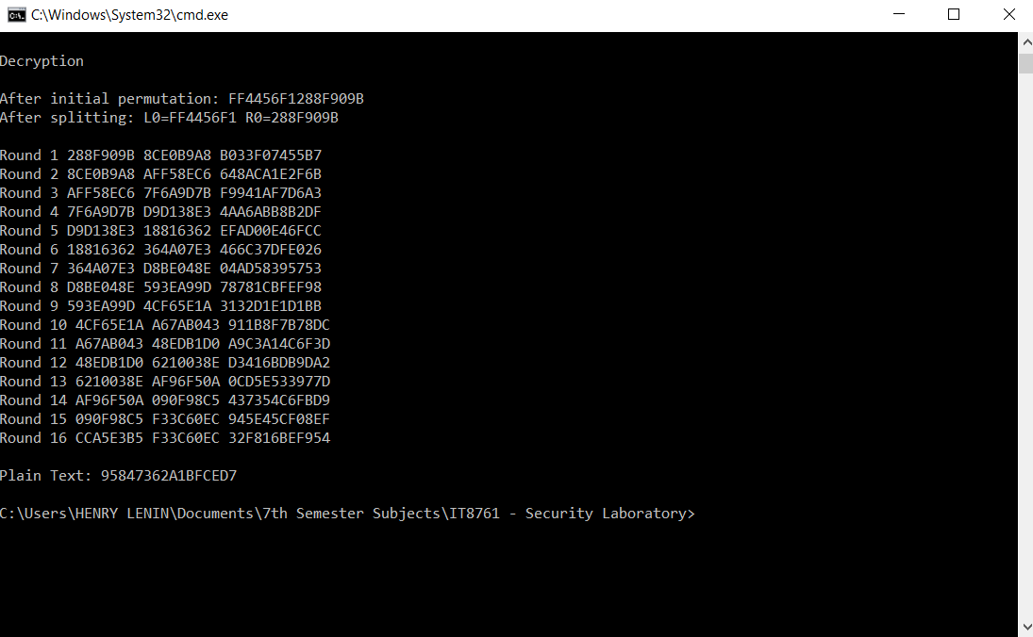

**RESULT:**

Thus, the program to implement Standard DES is executed successfully.

**EXPERIMENT NO.:4 - APPLICATIONS OF AES**

**AIM:**

To analyse the applications of AES algorithm and to implement the AES algorithm using a JAVA program.

**ALGORITHM:**

**Step 1:**Start the program.

**Step 2 (Substitution of the bytes):**In the first step, the bytes of the block text are substituted based on rules dictated by predefined S-boxes.

**Step 3 (Shifting the rows):**Next comes the permutation step. In this step, all rows except the first are shifted as one by one.

**Step 4 (Mixing the columns):**In the third step, the Hill Cipher is used to jumble up the message more by mixing the block’s columns.

**Step 5 (Adding the round key):**In the final step, the message is XOR-ed with the respective round key.

**Step 6:**When done repeatedly, these steps ensure that the final cipher text is secure.

**Step 7:** Terminate the program.

**SOURCE CODE:**

**import java.nio.charset.StandardCharsets;**

**import java.security.spec.KeySpec;**

**import java.util.Base64;**

**import javax.crypto.Cipher;**

**import javax.crypto.SecretKey;**

**import javax.crypto.SecretKeyFactory;**

**import javax.crypto.spec.IvParameterSpec;**

**import javax.crypto.spec.PBEKeySpec;**

**import javax.crypto.spec.SecretKeySpec;**

**import java.util.*;**

**class AES {**

**private static final String SECRET_KEY = "my_super_secret_key_ho_ho_ho";**

**private static final String SALT = "ssshhhhhhhhhhh!!!!";**

**public static String encrypt(String strToEncrypt)**

**{**

**try {**

**byte[] iv = { 0, 0, 0, 0, 0, 0, 0, 0, 0, 0, 0, 0, 0, 0, 0, 0 };**

**IvParameterSpec ivspec = new IvParameterSpec(iv);**

**SecretKeyFactory factory = SecretKeyFactory.getInstance("PBKDF2WithHmacSHA256");**

**KeySpec spec = new PBEKeySpec(SECRET_KEY.toCharArray(), SALT.getBytes(), 65536,256);**

**SecretKey tmp = factory.generateSecret(spec);**

**SecretKeySpec secretKey = new SecretKeySpec(tmp.getEncoded(), "AES");**

**Cipher cipher = Cipher.getInstance("AES/CBC/PKCS5Padding");**

**cipher.init(Cipher.ENCRYPT_MODE, secretKey,ivspec);**

**return Base64.getEncoder().encodeToString(**

**cipher.doFinal(strToEncrypt.getBytes(**

**StandardCharsets.UTF_8)));**

**}**

**catch (Exception e) {**

**System.out.println("Error while encrypting: " + e.toString());**

**}**

**return null;**

**}**

**public static String decrypt(String strToDecrypt)**

**{**

**try {**

**byte[] iv = { 0, 0, 0, 0, 0, 0, 0, 0, 0, 0, 0, 0, 0, 0, 0, 0 };**

**IvParameterSpec ivspec = new IvParameterSpec(iv);**

**SecretKeyFactory factory = SecretKeyFactory.getInstance("PBKDF2WithHmacSHA256");**

**KeySpec spec = new PBEKeySpec(SECRET_KEY.toCharArray(), SALT.getBytes(), 65536, 256);**

**SecretKey tmp = factory.generateSecret(spec);**

**SecretKeySpec secretKey = new SecretKeySpec(tmp.getEncoded(), "AES");**

**Cipher cipher = Cipher.getInstance("AES/CBC/PKCS5PADDING");**

**cipher.init(Cipher.DECRYPT_MODE, secretKey, ivspec);**

**return new String(cipher.doFinal(**

**Base64.getDecoder().decode(strToDecrypt)));**

**}**

**catch (Exception e) {**

**System.out.println("Error while decrypting: " + e.toString());**

**}**

**return null;**

**}**

**}**

**public class AESMain {**

**public static void main(String[] args)**

**{**

**Scanner sc= new Scanner(System.in);**

**System.out.print("Enter Original String : ");**

**String originalString = sc.nextLine();**

**String encryptedString = AES.encrypt(originalString);**

**String decryptedString = AES.decrypt(encryptedString);**

**System.out.println("The original String is " + originalString);**

**System.out.println("The encrypted String is " + encryptedString);**

**System.out.println("The decrypted String is " + decryptedString);**

**}**

**}**

**SAMPLE INPUT & OUTPUT:**

**Input:**

Enter Original String : Stay safe

**Output:**

The original String is Stay safe

The encrypted String is 3AX++Sle7HKiIsQ/dFmWvA==

The decrypted String is Stay safe

**OUTPUT SCREENSHOT:**

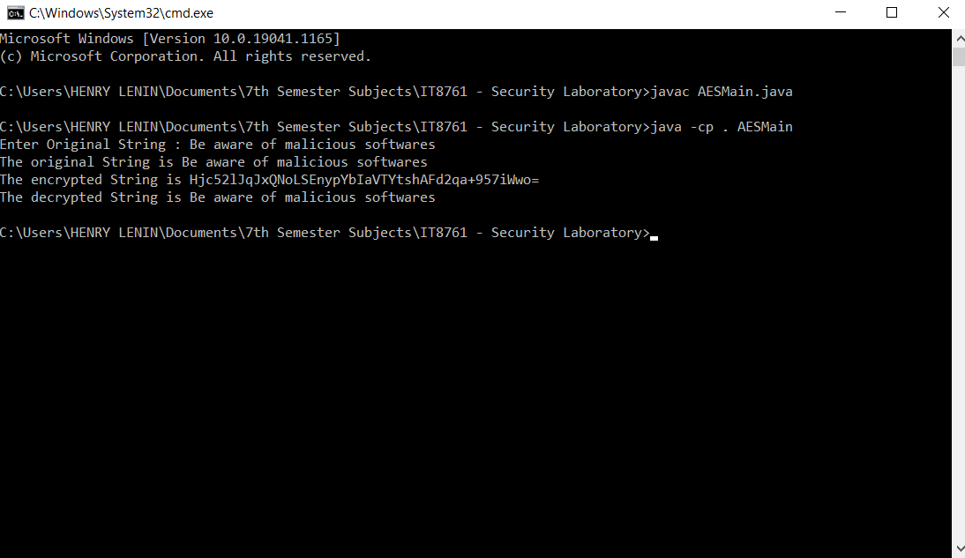

**RESULT:**

Thus, the program to implement AES algorithm is executed successfully.

**EXPERIMENT NO.:5–RSA ALGORITHM**

**AIM:**

To implement RSA (Rivest-Shamir-Adleman) algorithm using a C program.

**ALGORITHM:**

**Step 1:**Start the program.

**Step 2:**Choose two prime numbers p and q.

**Step 3:**Compute the values for the variables n and p.

**Step 4:**Find the value of e which is a public key.

**Step 5:**Compute the value of d which is a private key using gcd() function.

**Step 6:**Do the encryption and decryption as following:

* Encryption is given as, c = te mod n
* Decryption is given as, t = cd mod n

**Step 7:** Terminate the program.

**SOURCE CODE:**

**#include<stdio.h>**

**#include<conio.h>**

**#include<stdlib.h>**

**#include<math.h>**

**#include<string.h>**

**long int p,q,n,t,flag,e[100],d[100],temp[100],j,m[100],en[100],i;**

**char msg[100];**

**int prime(long int);**

**void ce();**

**long int cd(long int);**

**void encrypt();**

**void decrypt();**

**void main() {**

**printf("\nEnter first Prime Number : ");**

**scanf("%d",&p);**

**flag=prime(p);**

**if(flag==0) {**

**printf("\nThe number is not a Prime Number!");**

**getch();**

**exit(1);**

**}**

**printf("\nEnter second Prime Number : ");**

**scanf("%d",&q);**

**flag=prime(q);**

**if(flag==0||p==q) {**

**printf("\nThe number is not a Prime Number!");**

**getch();**

**exit(1);**

**}**

**printf("\nEnter the message : ");**

**fflush(stdin);**

**scanf("%s",msg);**

**for (i=0;msg[i]!='\0';i++)**

**m[i]=msg[i];**

**n=p*q;**

**t=(p-1)*(q-1);**

**ce();**

**printf("\nThe possible values of e and d are as follows:");**

**for (i=0;i<j-1;i++)**

**printf("\n%ld\t%ld",e[i],d[i]);**

**encrypt();**

**decrypt();**

**getch();**

**}**

**int prime(long int pr) {**

**int i;**

**j=sqrt(pr);**

**for (i=2;i<=j;i++) {**

**if(pr%i==0)**

**return 0;**

**}**

**return 1;**

**}**

**void ce() {**

**int k;**

**k=0;**

**for (i=2;i<t;i++) {**

**if(t%i==0)**

**continue;**

**flag=prime(i);**

**if(flag==1&&i!=p&&i!=q) {**

**e[k]=i;**

**flag=cd(e[k]);**

**if(flag>0) {**

**d[k]=flag;**

**k++;**

**}**

**if(k==99)**

**break;**

**}**

**}**

**}**

**long int cd(long int x) {**

**long int k=1;**

**while(1) {**

**k=k+t;**

**if(k%x==0)**

**return(k/x);**

**}**

**}**

**void encrypt() {**

**long int pt,ct,key=e[0],k,len;**

**i=0;**

**len=strlen(msg);**

**while(i!=len) {**

**pt=m[i];**

**pt=pt-96;**

**k=1;**

**for (j=0;j<key;j++) {**

**k=k*pt;**

**k=k%n;**

**}**

**temp[i]=k;**

**ct=k+96;**

**en[i]=ct;**

**i++;**

**}**

**en[i]=-1;**

**printf("\nThe encrypted message is : ");**

**for (i=0;en[i]!=-1;i++)**

**printf("%c",en[i]);**

**}**

**void decrypt() {**

**long int pt,ct,key=d[0],k;**

**i=0;**

**while(en[i]!=-1) {**

**ct=temp[i];**

**k=1;**

**for (j=0;j<key;j++) {**

**k=k*ct;**

**k=k%n;**

**}**

**pt=k+96;**

**m[i]=pt;**

**i++;**

**}**

**m[i]=-1;**

**printf("\nThe decrypted message is : ");**

**for (i=0;m[i]!=-1;i++)**

**printf("%c",m[i]);**

**}**

**SAMPLE INPUT & OUTPUT:**

**Input:**

Enter first Prime Number : 23

Enter second Prime Number : 31

Enter the message : Cyberattack

**Output:**

The possible values of e and d are as follows:

7 283

13 457

17 233

19 139

29 569

37 553

41 161

43 307

47 323

53 137

59 179

61 541

67 463

71 251

73 217

79 259

83 167

89 89

97 313

101 281

103 487

107 623

The encrypted message is : ┘»α°←aëëaÉ

The decrypted message is : Cyberattack

**OUTPUT SCREENSHOT:**

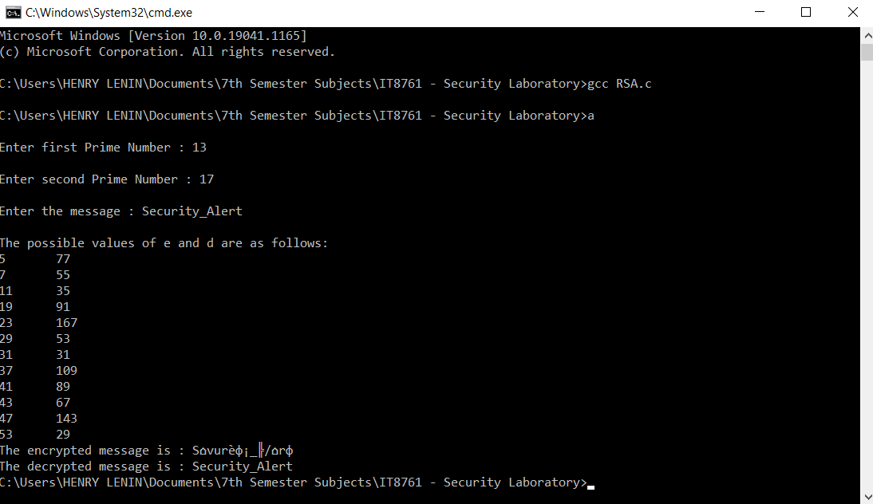

**RESULT:**

Thus, the program to implement RSA algorithm is executed successfully.

**EXPERIMENT NO.:6–DIFFIE HELLMAN KEY EXCHANGE ALGORITHM**

**AIM:**

To implement Diffie Hellman Key Exchange algorithm for a given problem using a C program.

**ALGORITHM:**

**Step 1:**Start the program.

**Step 2:**Alice and Bob publicly agree to use a modulus p = 23 and base g = 5 (which is a primitive root modulo 23).

**Step 3:**Alice chooses a secret integer a = 4, then sends Bob A = ga mod p.**A = 54 mod 23 = 4**

**Step 4:**Bob chooses a secret integer b = 3, then sends Alice B = gb mod p.**B = 53 mod 23 = 10**

**Step 5:**Alice computes s = Ba mod p.**s = 104 mod 23 = 18**

**Step 6:**Bob computes s = Ab mod p. **s = 43 mod 23 = 18**

**Step 7:** Alice and Bob now share the secret key (the number 18).

**Step 8:** Terminate the program.

**SOURCE CODE:**

**#include<stdio.h>**

**#include<math.h>**

**long long int power(long long int a, long long int b,long long int P)**

**{**

**if (b == 1)**

**return a;**

**else**

**return (((long long int)pow(a, b)) % P);**

**}**

**int main()**

**{**

**long long int P, G, x, a, y, b, ka, kb;**

**//P = 23;**

**scanf("%lld",&P);**

**printf("The value of P : %lld\n", P);**

**G = 9;**

**printf("The value of G : %lld\n\n", G);**

**a = 4;**

**printf("The private key a for Alice : %lld\n", a);**

**x = power(G, a, P);**

**b = 3;**

**printf("The private key b for Bob : %lld\n\n", b);**

**y = power(G, b, P);**

**ka = power(y, a, P);**

**kb = power(x, b, P);**

**printf("Secret key for the Alice is : %lld\n", ka);**

**printf("Secret Key for the Bob is : %lld\n\n", kb);**

**if(ka==kb)**

**printf("Secret message is shared successfully!");**

**else**

**printf("Error occurred in exchanging the secret key! Try again!");**

**return 0;**

**}**

**SAMPLE INPUT & OUTPUT:**

**Input:**

13

**Output:**

The value of P : 13

The value of G : 9

The private key a for Alice : 4

The private key b for Bob : 3

Secret key for the Alice is : 1

Secret Key for the Bob is : 1

Secret message is shared successfully!

**OUTPUT SCREENSHOT:**

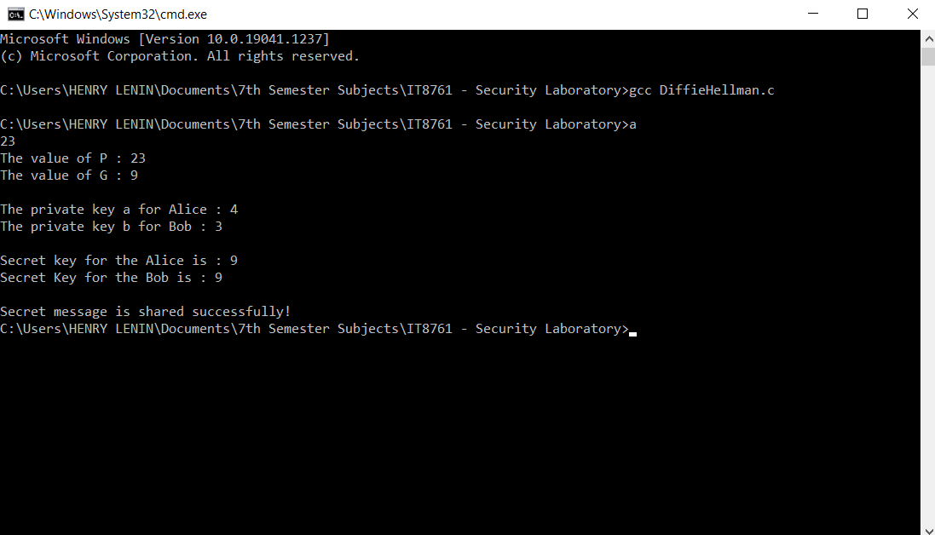

**RESULT:**

Thus, the program to implement Diffie Hellman Key Exchange algorithm is executed successfully.

**EXPERIMENT NO.:7–SHA-1 ALGORITHM**

**AIM:**

To calculate the message digest of a text using the Secure Hash Algorithm (SHA-1).

**ALGORITHM:**

**Step 1:**Start the program.

**Step 2:**Append Padding Bits.

**Step 3:**Append Length - 64 bits are appended to the end.

**Step 4:**Prepare Processing Functions.

**Step 5:**Prepare Processing Constants.

**Step 6:**Initialize Buffers.

**Step 7:** Processing Message in 512-bit blocks (L blocks in total message).

**Step 8:** Terminate the program.

**SOURCE CODE:**

**import java.math.BigInteger;**

**import java.security.MessageDigest;**

**import java.security.NoSuchAlgorithmException;**

**import java.util.*;**

**public class SHA_1_Algo {**

**public static String encryptThisString(String input)**

**{**

**try {**

**MessageDigest md = MessageDigest.getInstance("SHA-1");**

**byte[] messageDigest = md.digest(input.getBytes());**

**BigInteger no = new BigInteger(1, messageDigest);**

**String hashtext = no.toString(16);**

**while (hashtext.length() < 32) {**

**hashtext = "0" + hashtext;**

**}**

**return hashtext;**

**}**

**catch (NoSuchAlgorithmException e) {**

**throw new RuntimeException(e);**

**}**

**}**

**public static void main(String args[]) throws**

**NoSuchAlgorithmException**

**{**

**Scanner sc = new Scanner(System.in);**

**System.out.print("Enter a string : ");**

**String str = sc.nextLine();**

**System.out.println("\n\"HashCode Generated by SHA-1 for the given string\"");**

**System.out.println("\n" + str + " : " + encryptThisString(str));**

**}**

**}**

**SAMPLE INPUT & OUTPUT:**

**Input:**

Prevention is better than cure.

**Output:**

"Hash Code Generated by SHA-1 for the given string"

Prevention is better than cure. : 25a8509ce7a5ed0ffd87997863bf71cd00999e81

**OUTPUT SCREENSHOT:**

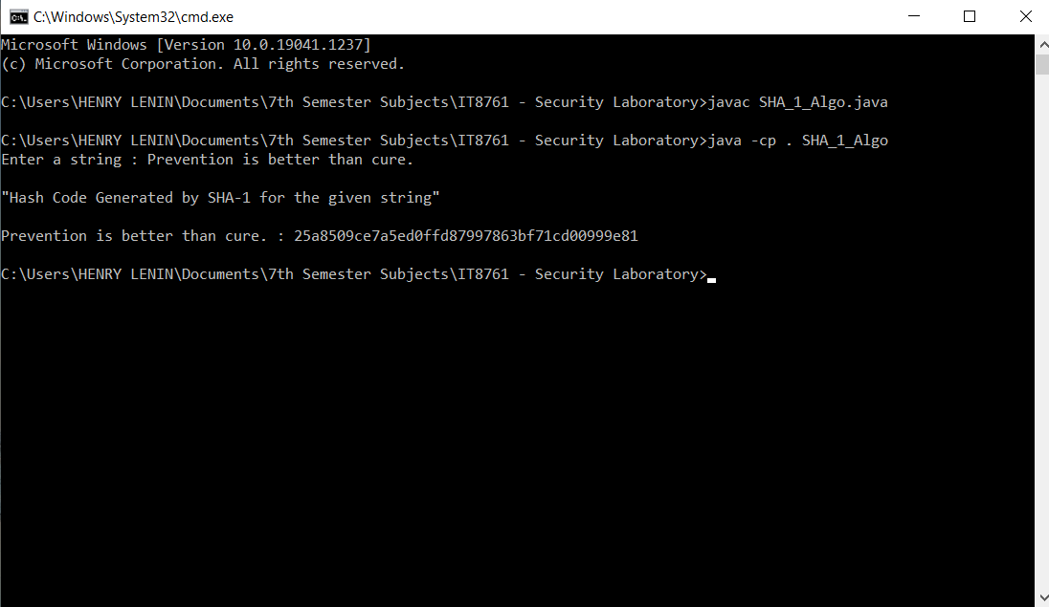

**RESULT:**

Thus, the Secure Hash Algorithm (SHA-1) has been implemented and the output has been verified successfully.

**EXPERIMENT NO.:8–DIGITAL SIGNATURE STANDARD**

**AIM:**

To implement the signature scheme – Digital Signature Standard.

**ALGORITHM:**

**Step 1:**Start the program.

**Step 2:**Create a Key Pair Generator object.

**Step 3:**Initialize the Key Pair Generator object.

**Step 4:**Generate the Key Pair Generator.

**Step 5:**Create a Signature object.

**Step 6:**Initialize the Signature object.

**Step 7:** Add data to the Signature object.

**Step 8:** Calculate the Signature.

**Step 8:** Terminate the program.

**SOURCE CODE:**

**import java.security.KeyPair;**

**import java.security.KeyPairGenerator;**

**import java.security.PrivateKey;**

**import java.security.Signature;**

**import java.util.Scanner;**

**public class DigitalSignatureStandard**

**{**

**public static void main(String args[]) throws Exception**

**{**

**Scanner sc = new Scanner(System.in);**

**System.out.println("Enter Message:-");**

**String msg = sc.nextLine();**

**KeyPairGenerator keyPairGen = KeyPairGenerator.getInstance("DSA");**

**keyPairGen.initialize(2048);**

**KeyPair pair = keyPairGen.generateKeyPair();**

**PrivateKey privKey = pair.getPrivate();**

**Signature sign = Signature.getInstance("SHA256withDSA");**

**sign.initSign(privKey);**

**byte[] bytes = "msg".getBytes();**

**sign.update(bytes);**

**byte[] signature = sign.sign();**

**System.out.println("Digital Signature:- "+new String(signature,"UTF8"));**

**}**

**}**

**SAMPLE INPUT & OUTPUT:**

**Input:**

Enter Message:- Stay Home! Stay Safe!

**Output:**

DigitalSignature:- 0<☻∟‼??♠!w3?<?PpQ?2ol??K?/Zk@??☻∟55▼?♫?] ?:q?∟+ ci?aA?u?↕?ew?

**OUTPUT SCREENSHOT:**

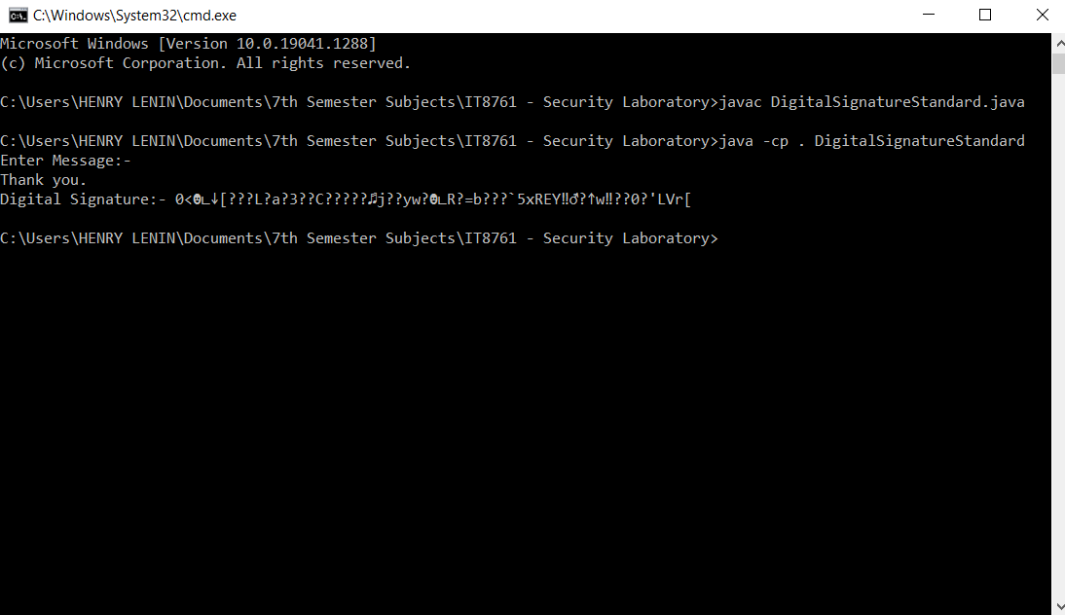

**RESULT:**

Thus, the Digital Signature Standard Scheme has been implemented and the output has been verified successfully.

**EXPERIMENT NO.:9–INTRUSION DETECTION**

**AIM:**

To demonstrate intrusion detection system using a software, Snort.

**ALGORITHM:**

**Step 1:**Sniffer mode **snort –v**prints out the TCP/IP packets header on the screen.

**Step 2:snort –vd** shows the TCP/IP ICMP header with application data in transit.

**Step 3:**Packet Logger mode **snort –dev –l c:\log** [create this directory in the C drive] and snort willautomatically know to go into packet logger mode, it collects every packet it sees and places it in the logdirectory.

**Step 4:snort –dev –l c:\log –h ipaddress/24**. This rule tells snort that you want to print out the data linkand TCP/IP headers as well as application data into the log directory.

**Step 5:snort –l c:\log –b** this binary mode logs everything into a single file.

**Step 6:**Network Intrusion Detection System mode **snort –d c:\log –h ipaddress/24 –c snort.conf.** This isa configuration file that applies rule to each packet to decide it an action based upon the rule type in thefile.

**Step 7: snort –d –h ipaddress/24 –l c:\log –c snort.conf.** This will configure snort to run in its most basicNIDS form, logging packets that trigger rules specifies in the **snort.conf**.

**Step 8:** Download SNORT from snort.org. Install snort with or without database support.

**Step 9:**Select all the components and Click Next. Install and Close.

**Step 10:** Create a path variable and point it at snort.exe variable name path and variable value

**c:\snort\bin**.

**Step 11:** Click the OK button and then close all dialog boxes. Open command prompt and type thefollowing commands:

**cd bin**

**snort.exe**

**SCREENSHOTS:**

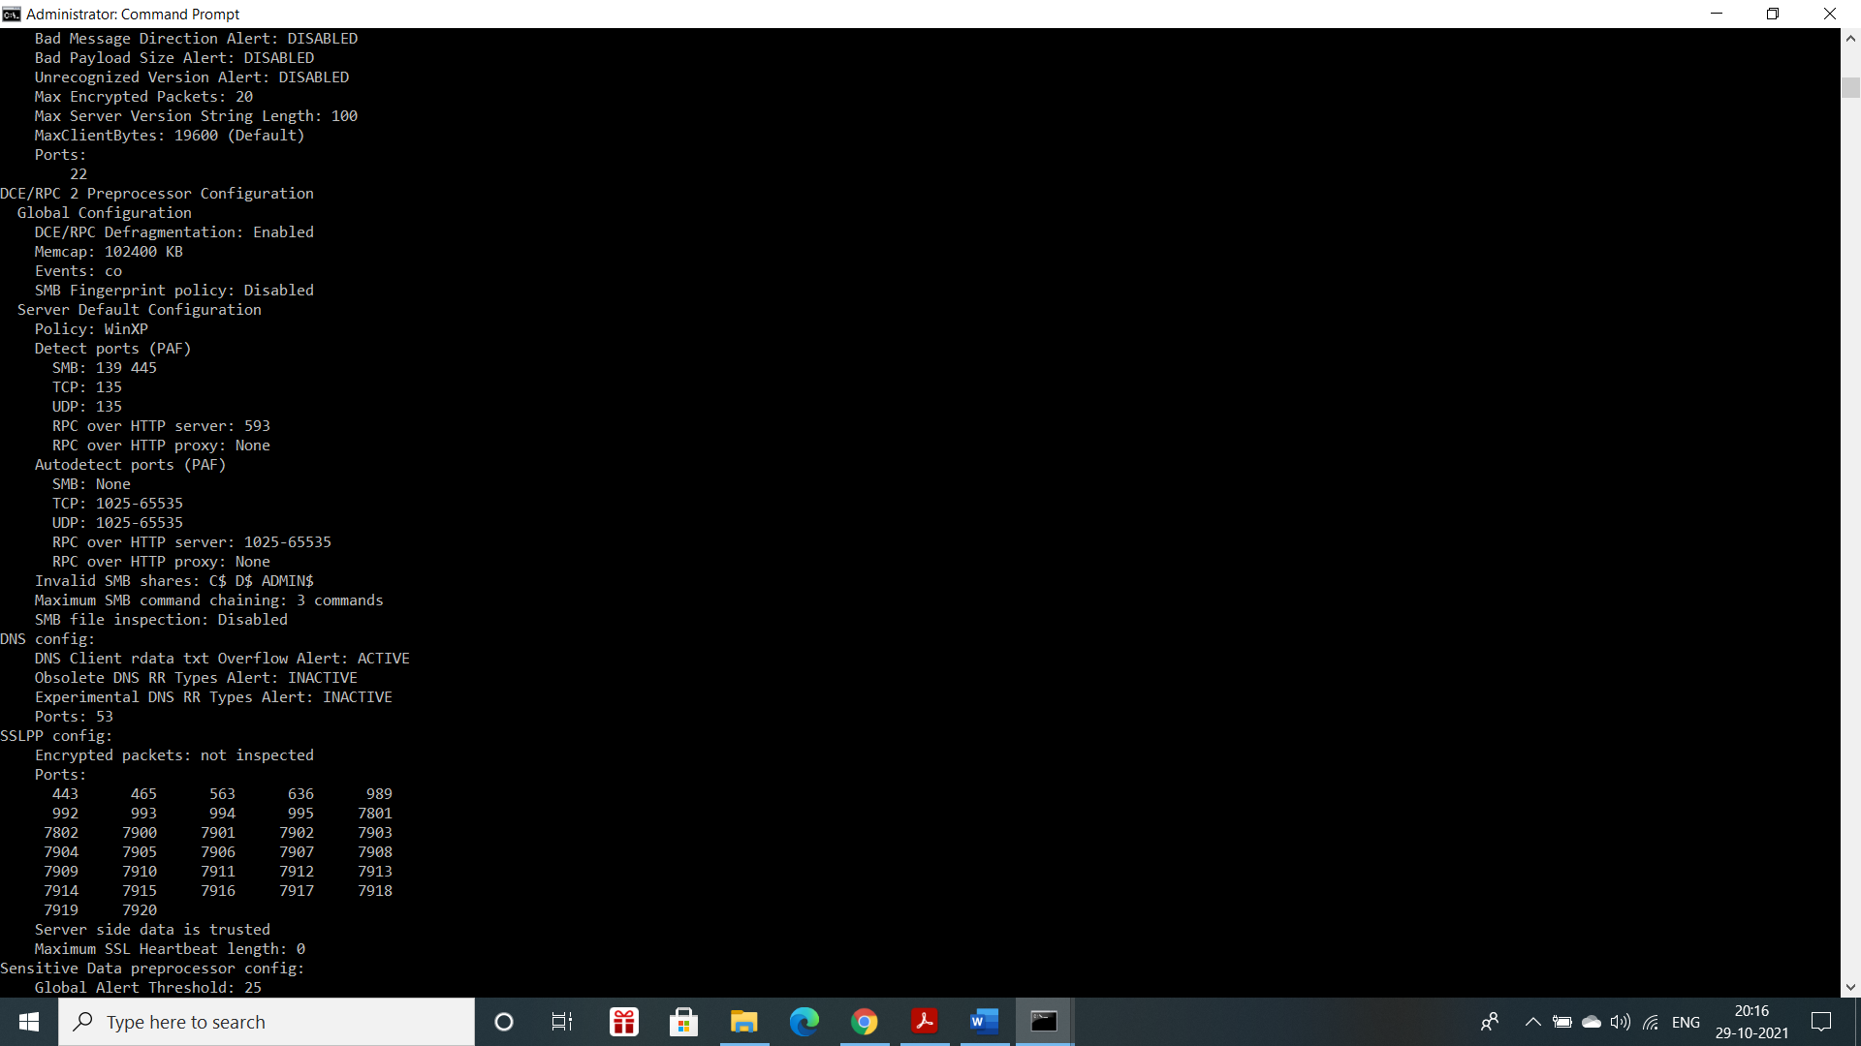

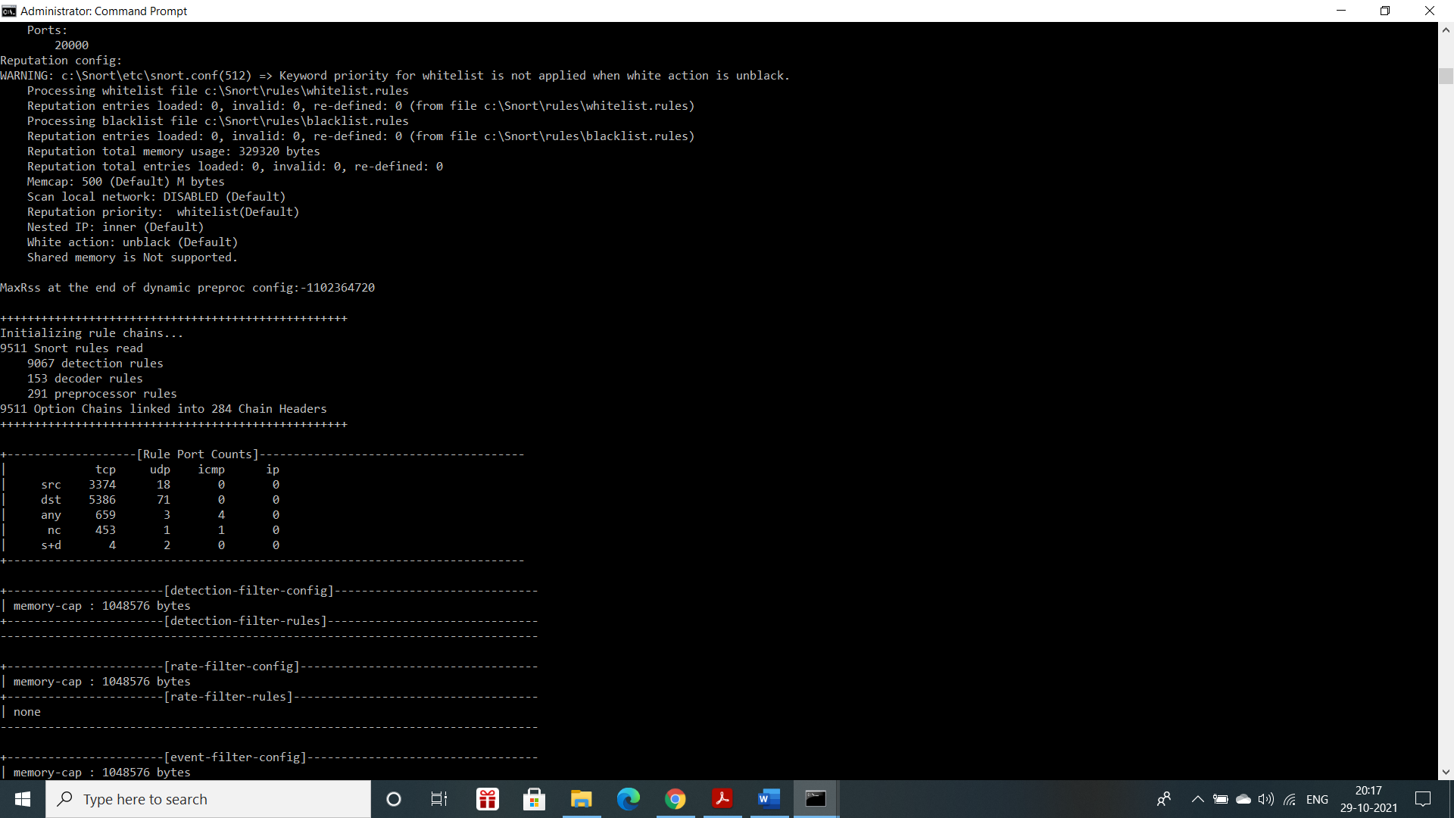

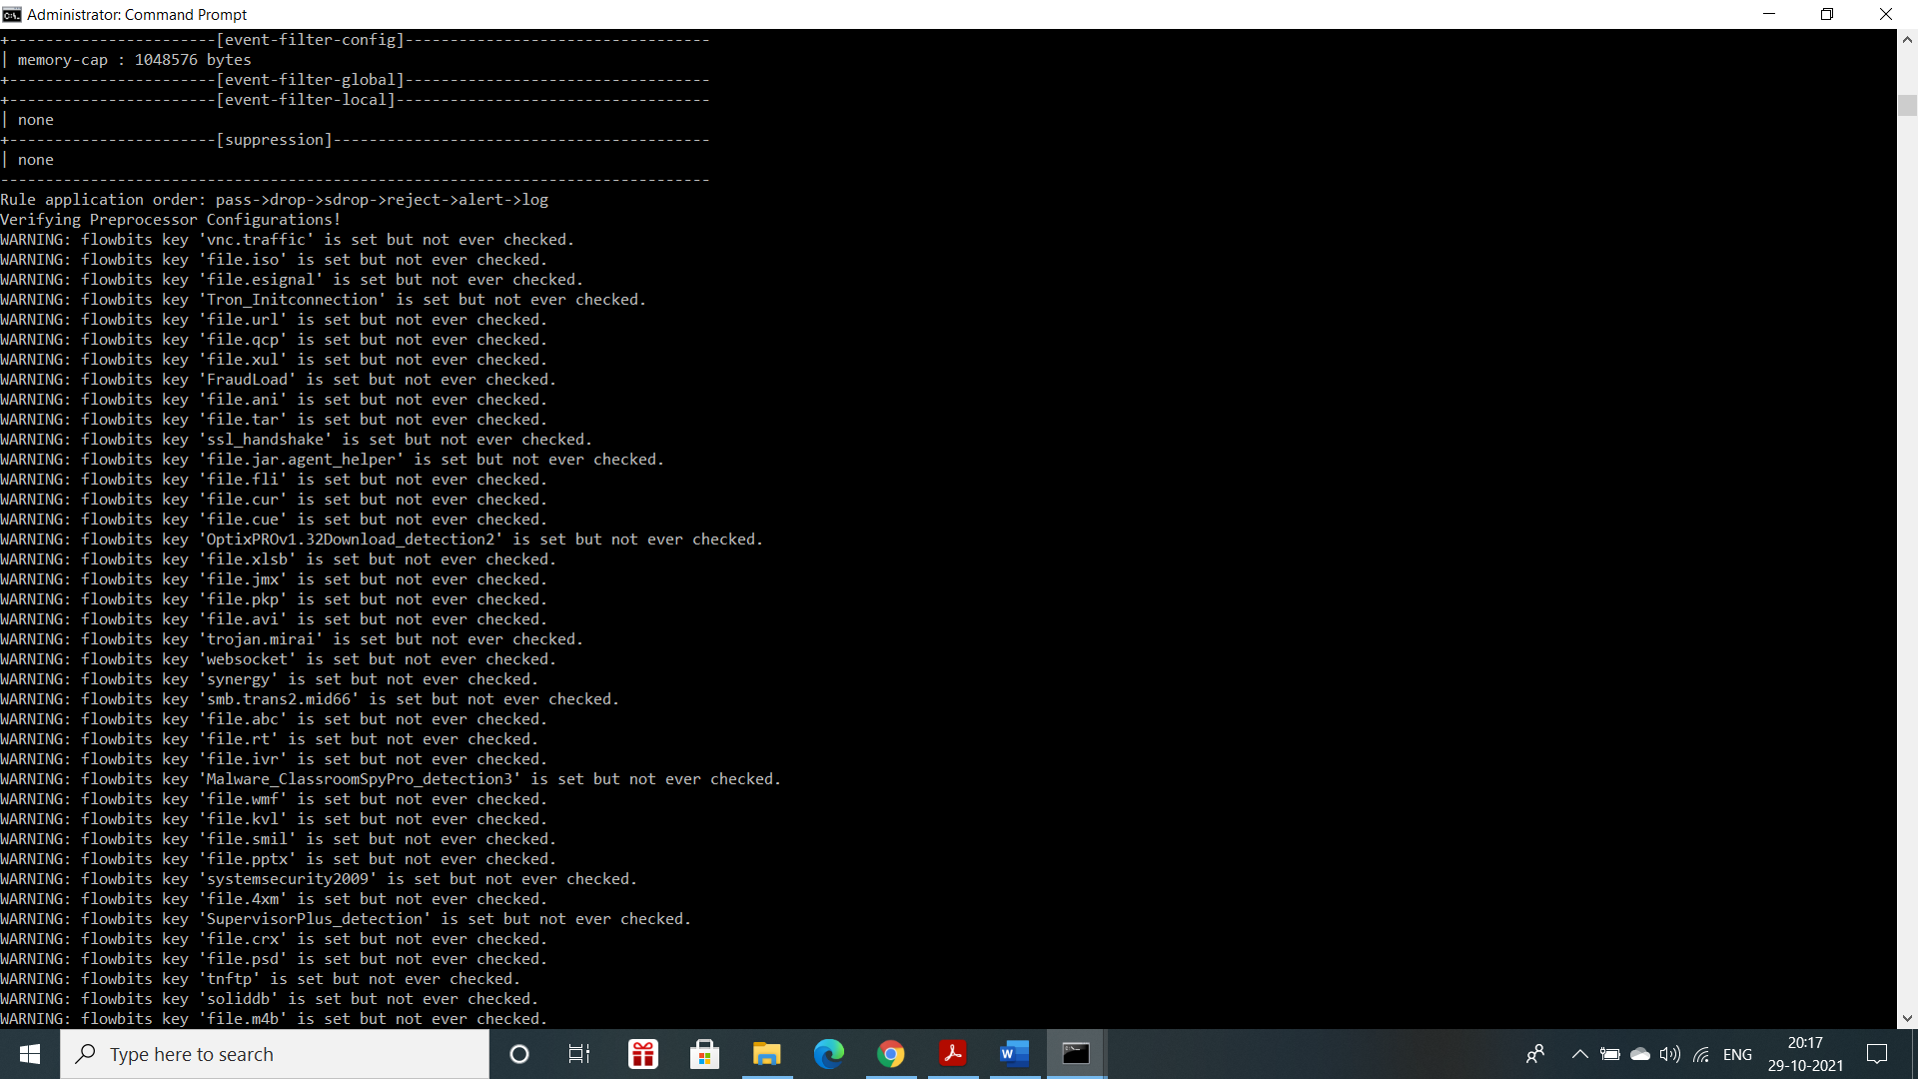

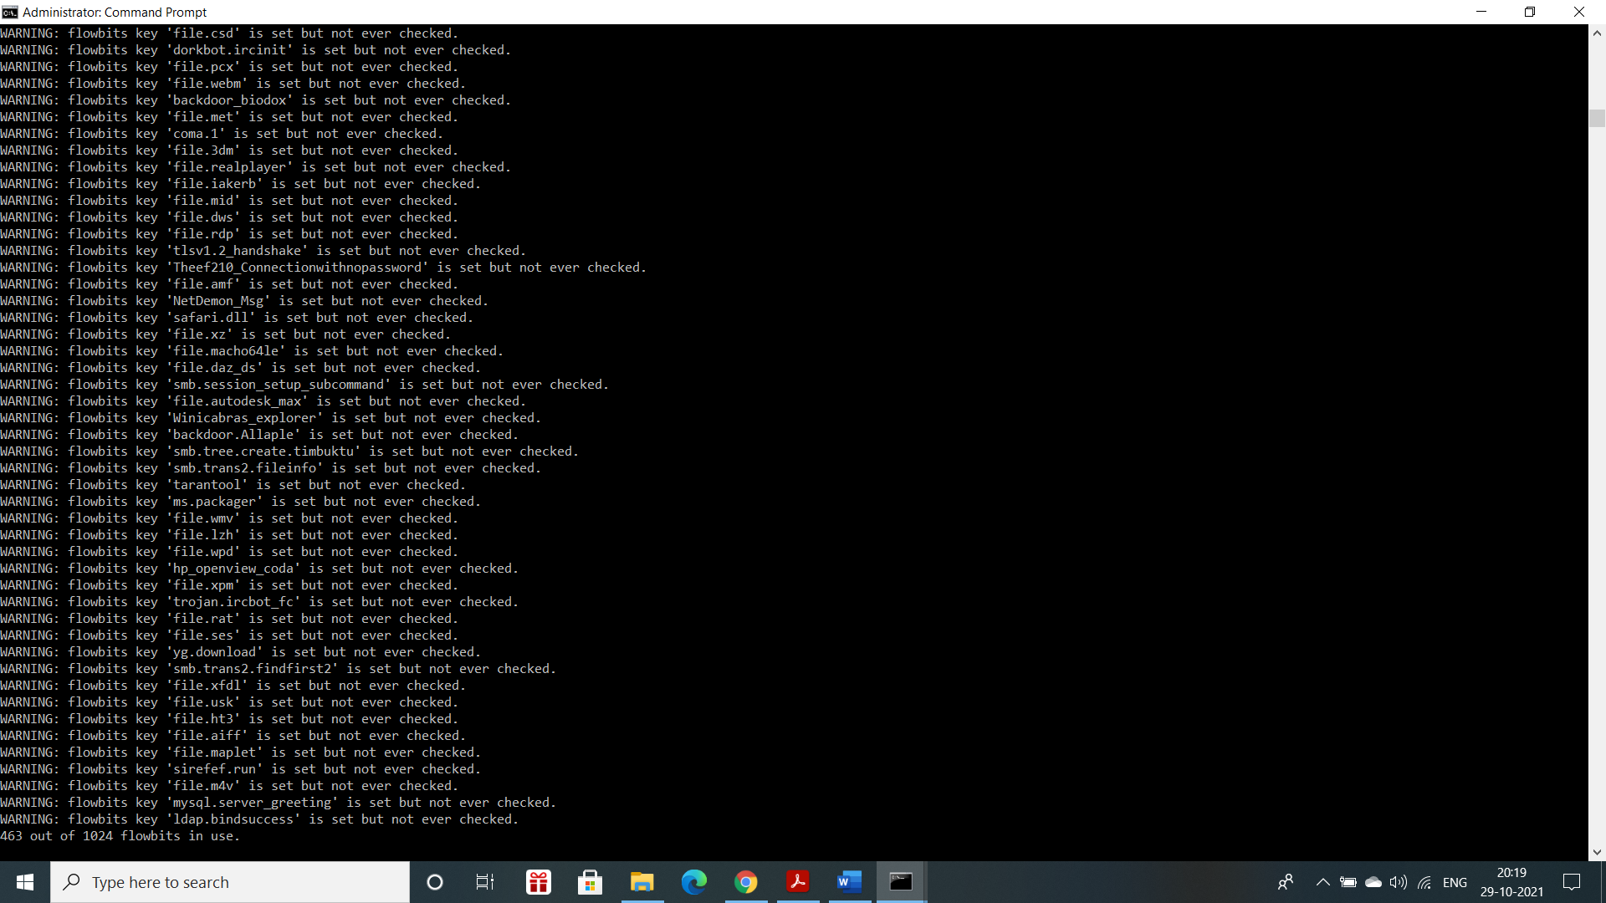

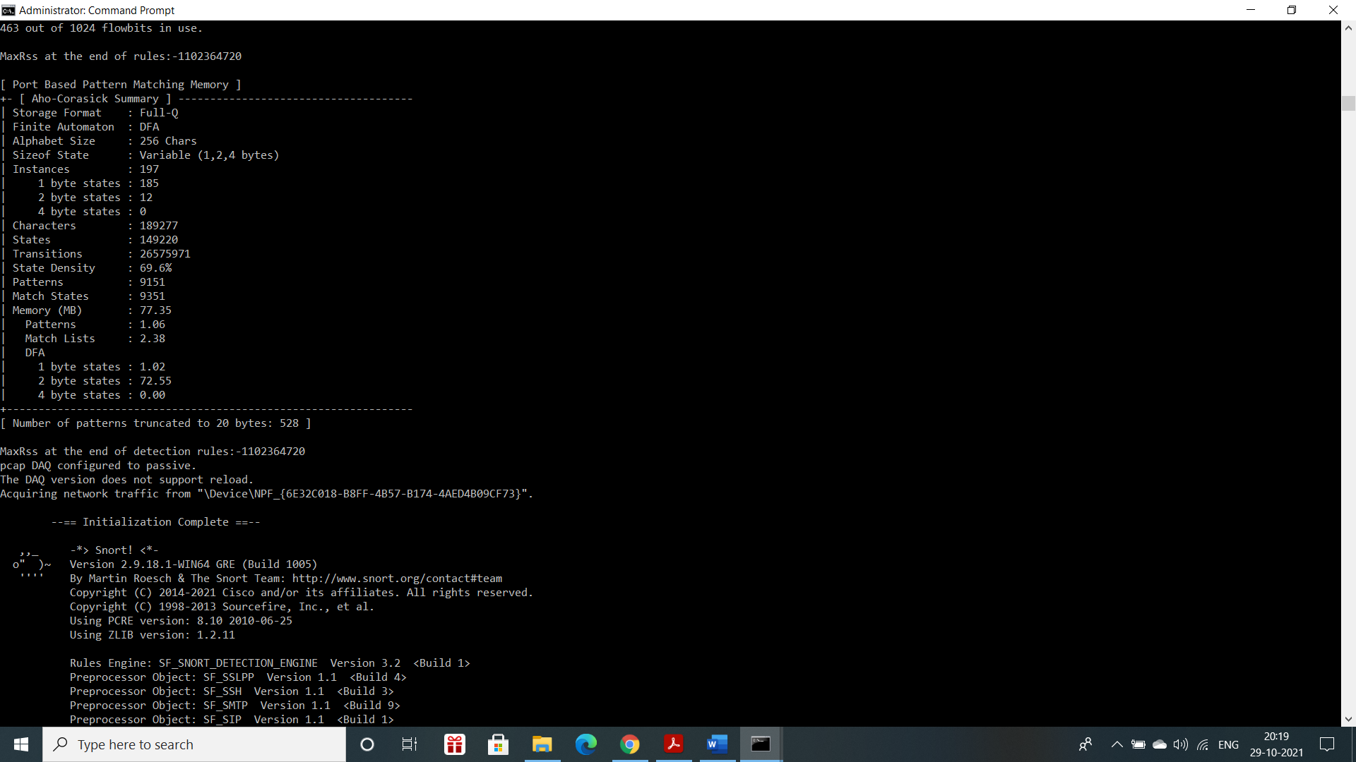

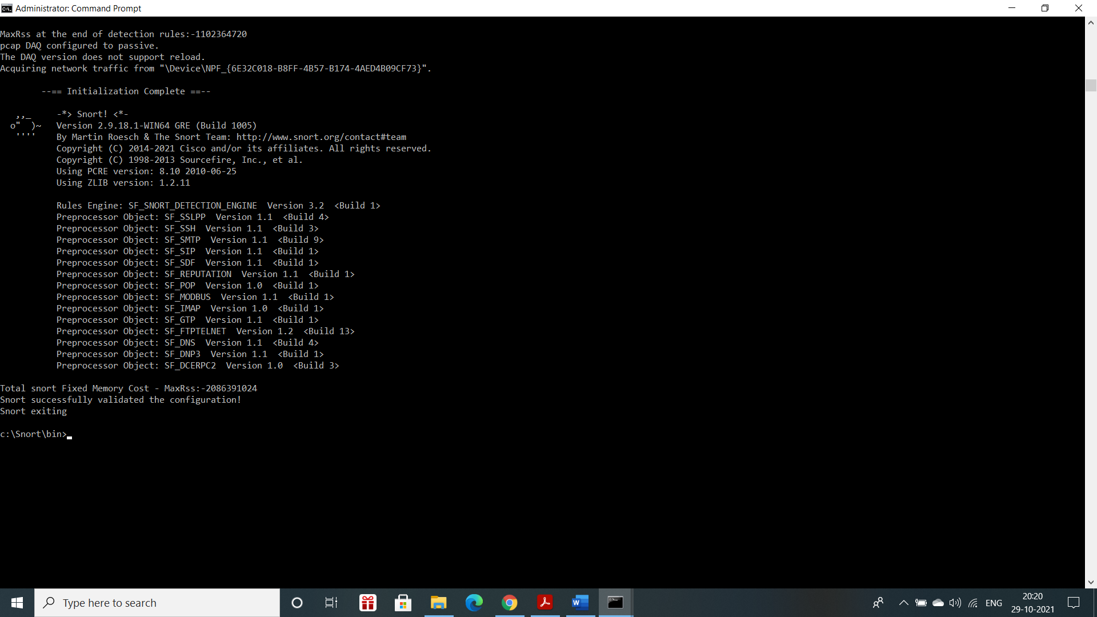

**RESULT:**

Thus, the demonstration of intrusion detection system using a software, Snort was successfully written and executed.

**EXPERIMENT NO.:10–EXPLORING N-STALKER**

**AIM:**

To download and install the N-Stalker Vulnerability Assessment Tool and exploring the features.

**THEORY:**

* N-Stalker Web Application Security Scanner is a Web security assessment tool.
* It incorporates with a well-known N-Stealth HTTP Security Scanner and 39,000 Web attacksignature databases.
* This tool also comes in both free and paid version.
* N-Stalker can be downloaded by visiting <https://www.nstalker.com/>

**DOWNLOADING STEPS:**



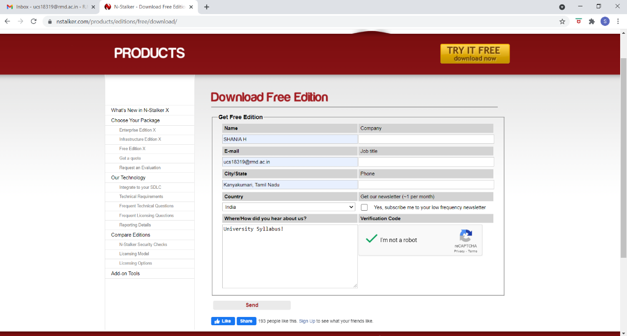

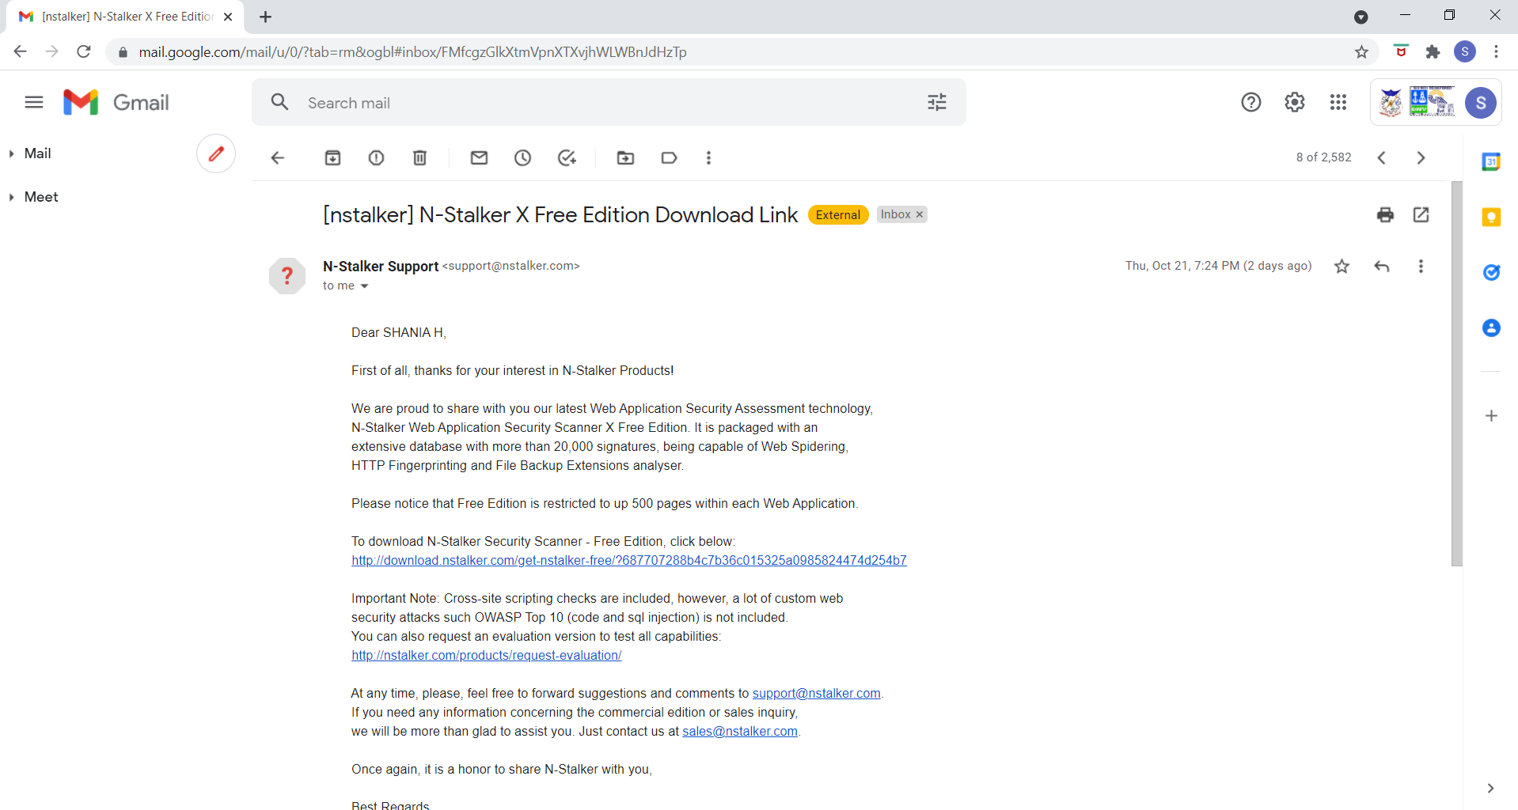

**INSTALLATION STEPS:**



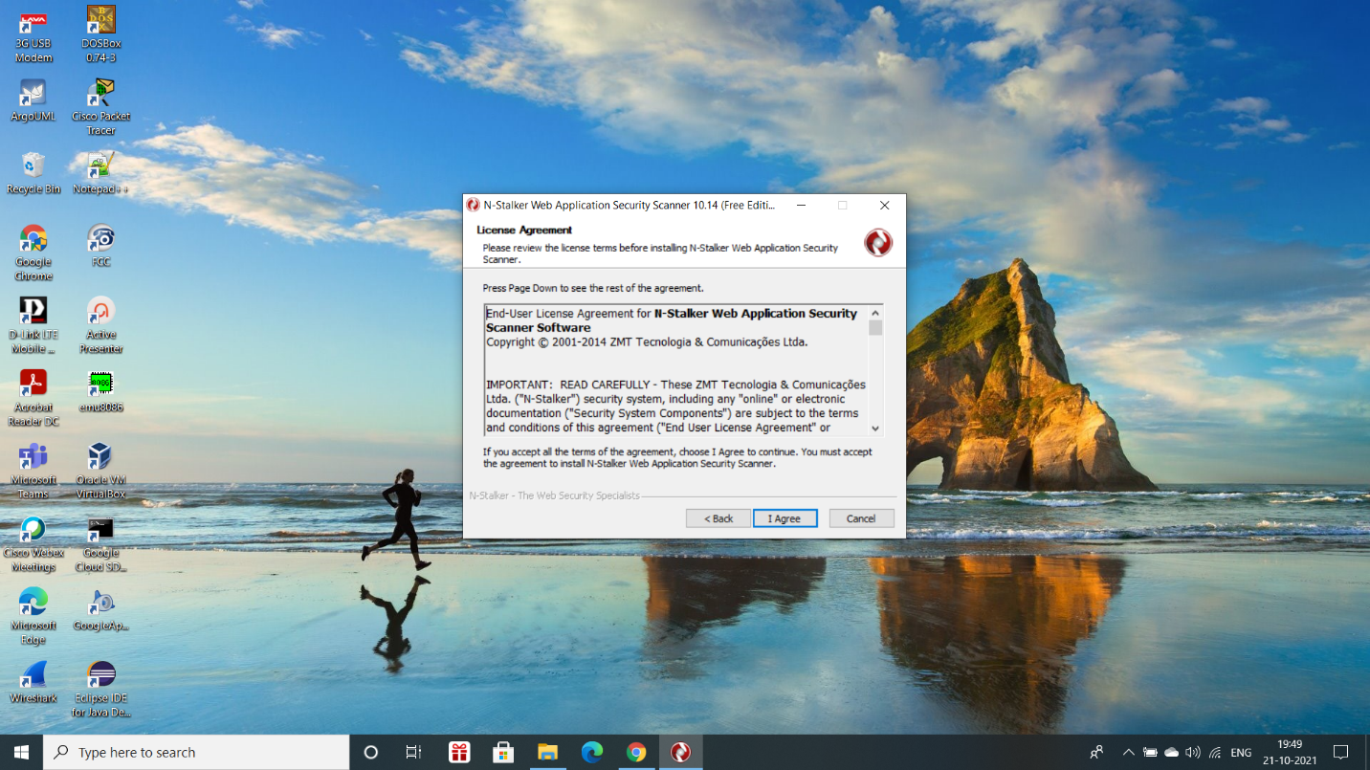

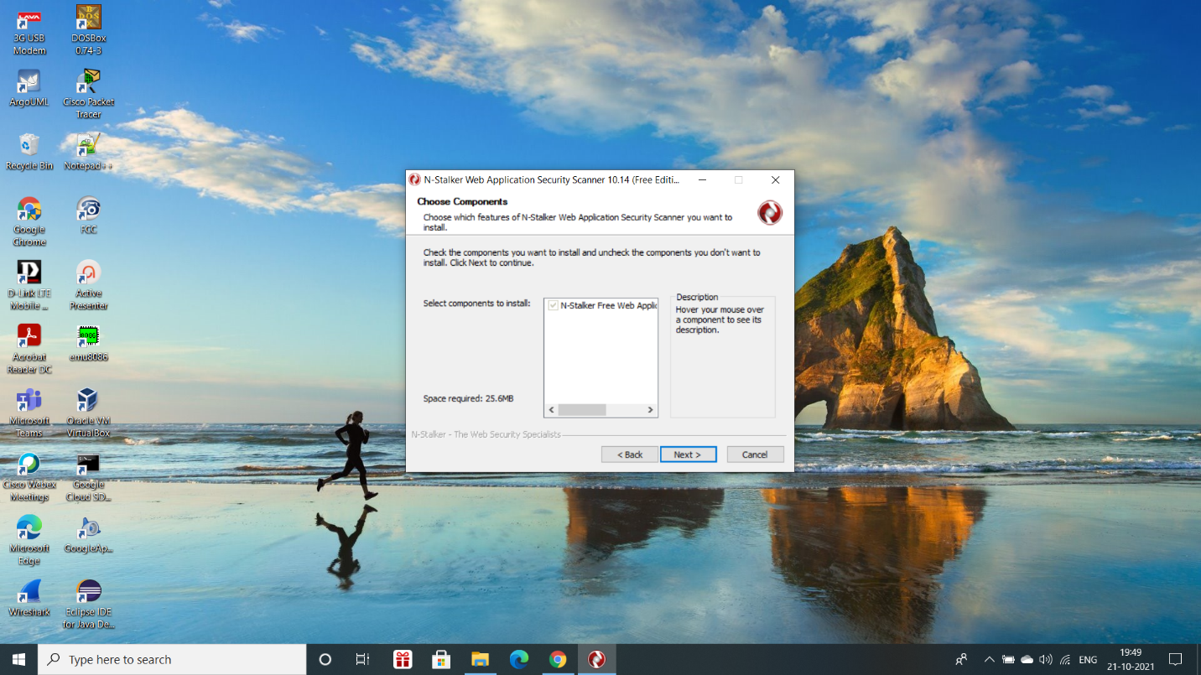

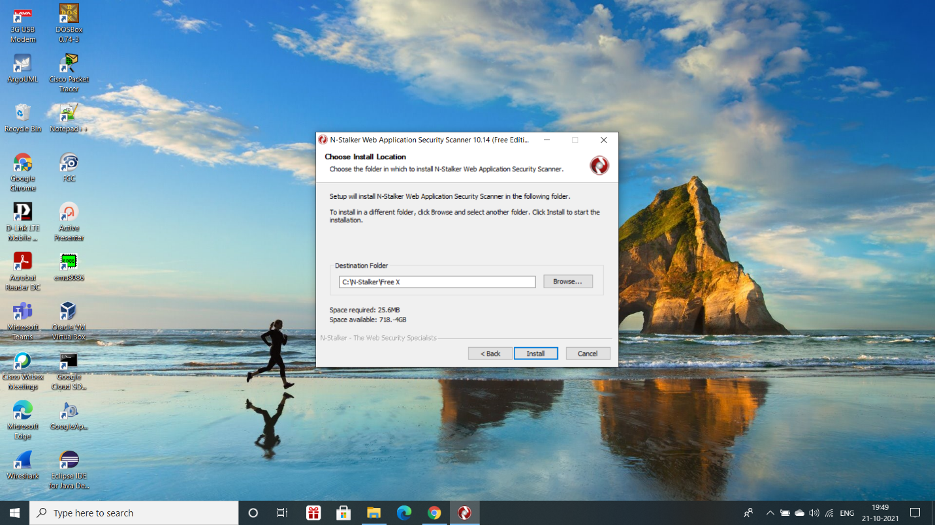

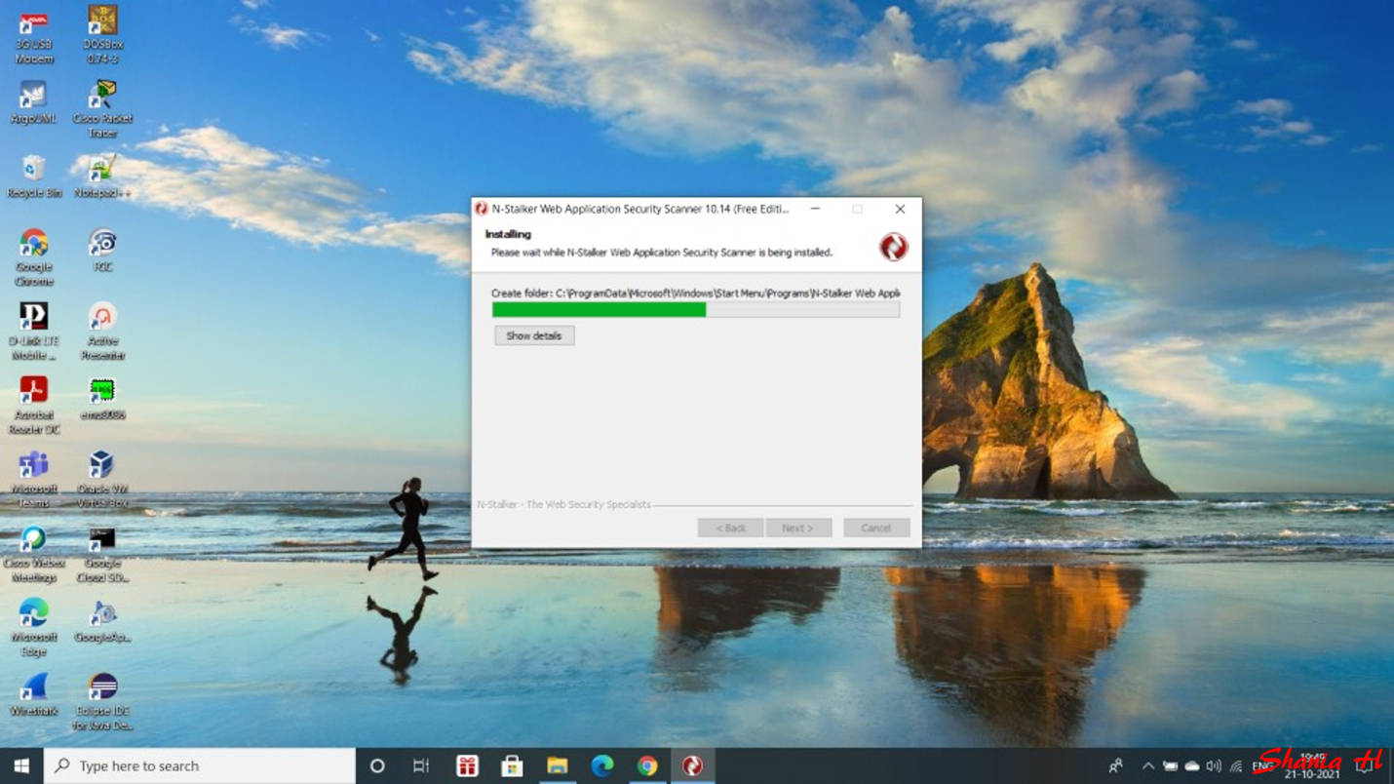

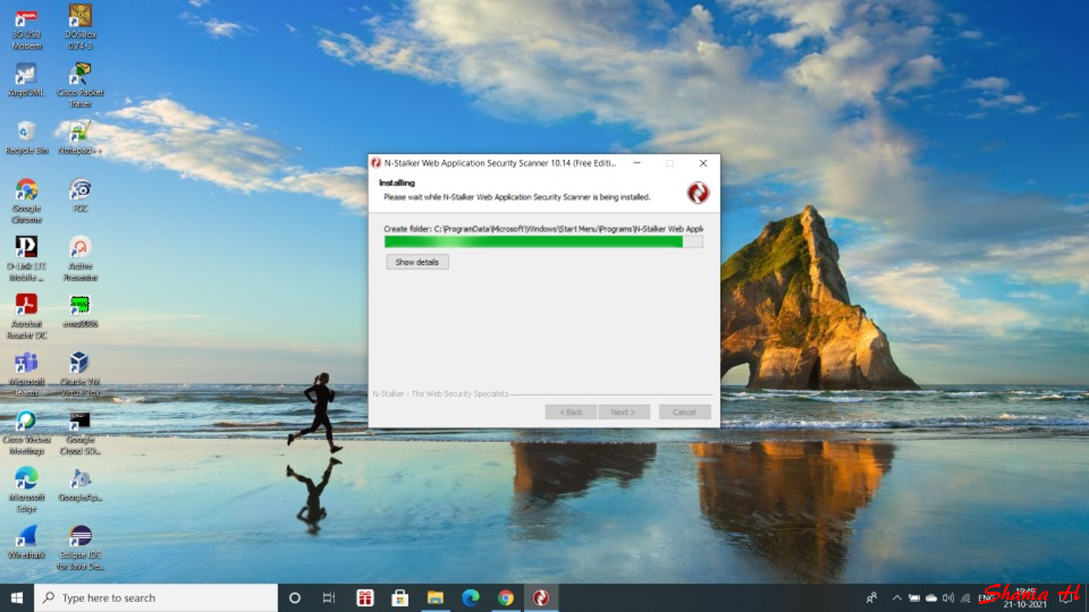



**WORKING OF N-STALKER:**

**Step 1:** Initiate the application, you should either search for N-Stalker icon in your desktop or

"N-Stalker Web Application Security Scanner" group in your start menu.



**Step 2:** Click update manager in the top menu bar and click update button to update all the

services provided by N-Stalker.

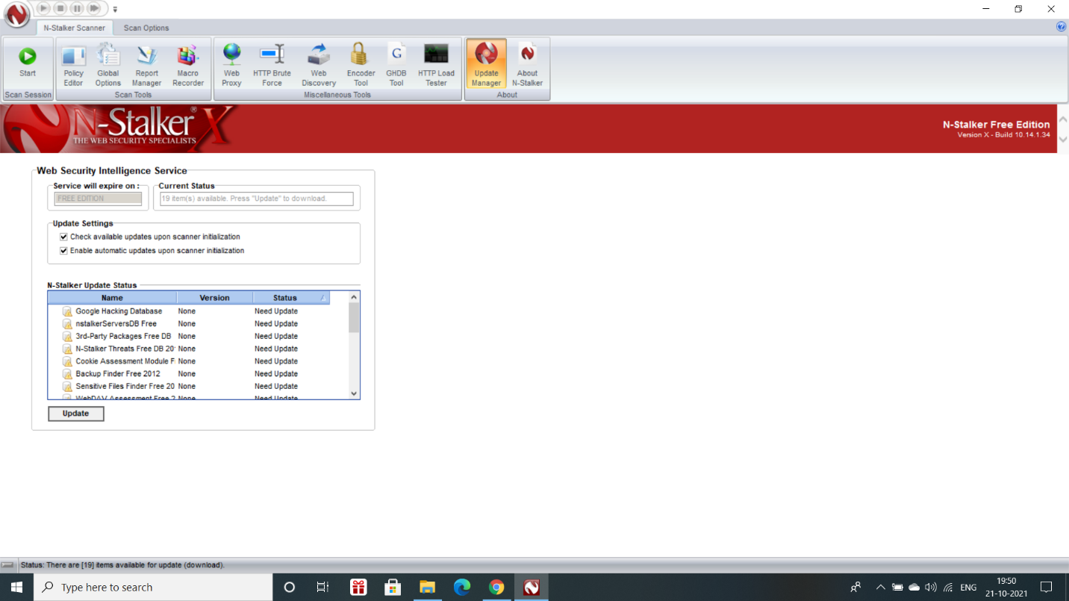

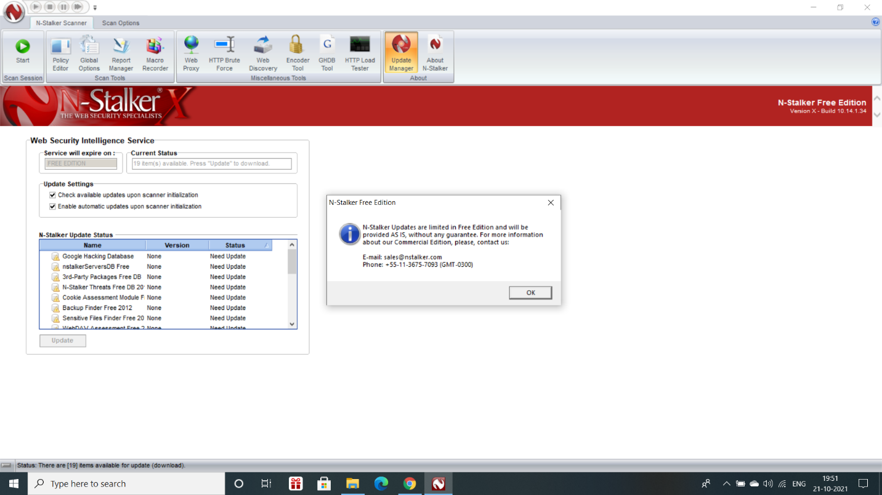

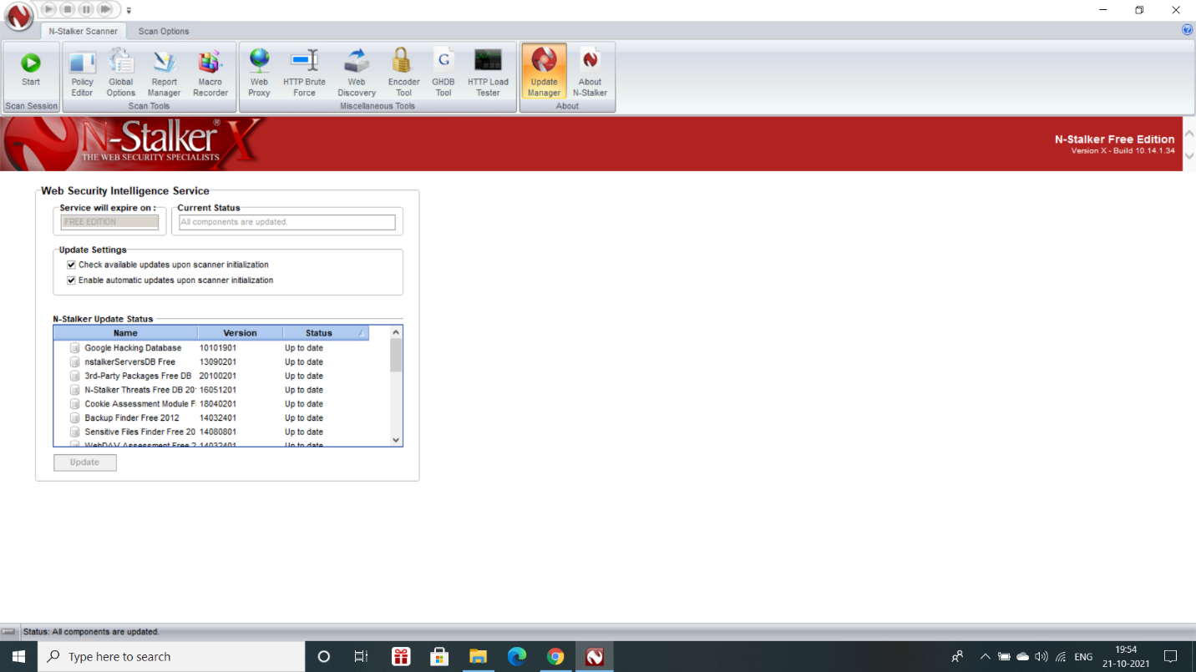

**Step 3:** Click Start button in the top left corner to get the N-Stalker Scan Wizard.

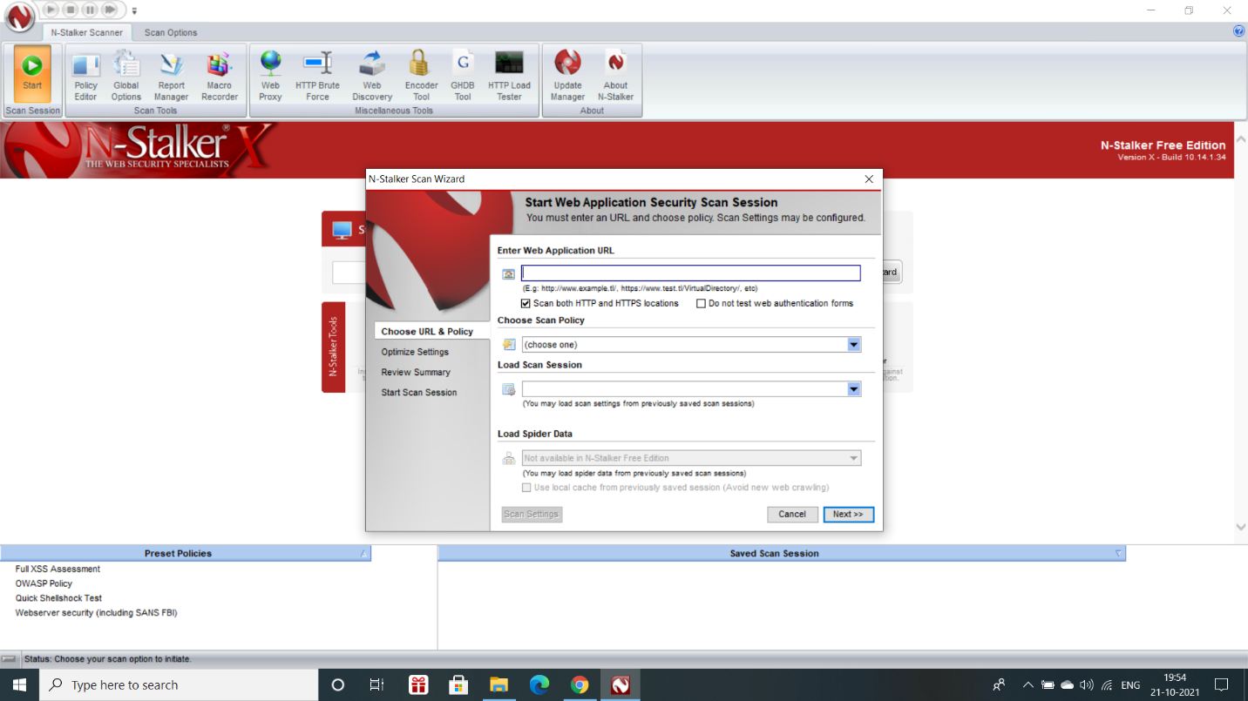

**Step 4:** Enter the target URL.

In scan policy, we can select from the four options,

* Manual test which will crawl the website and will be waiting for manual attacks.
* Full xss assessment
* OWASP policy
* Web server infrastructure analysis.

Once, the option has been selected, click Next in the Scan Wizard.

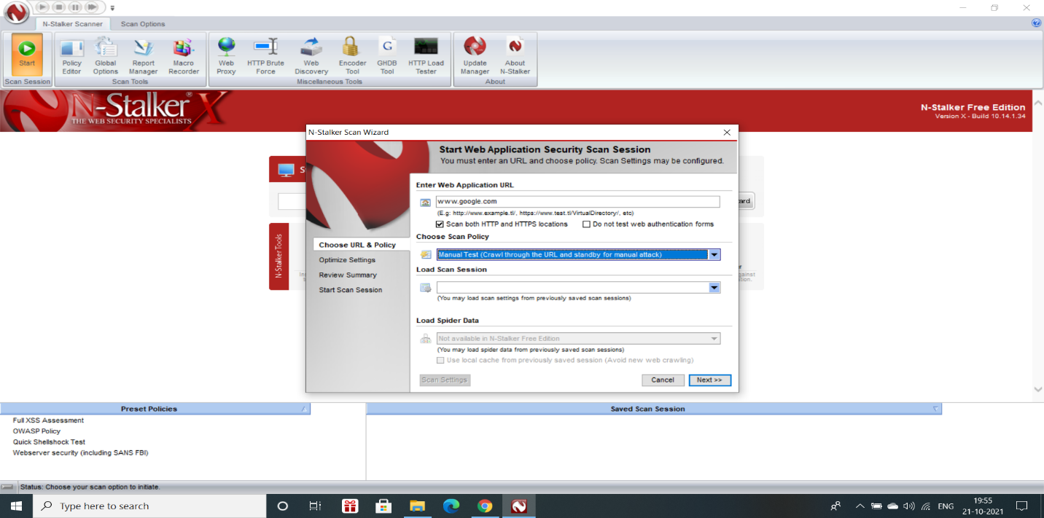

**Step 5:** Click optimize. “Optimize settings” which will crawl the whole website for further

analysis.

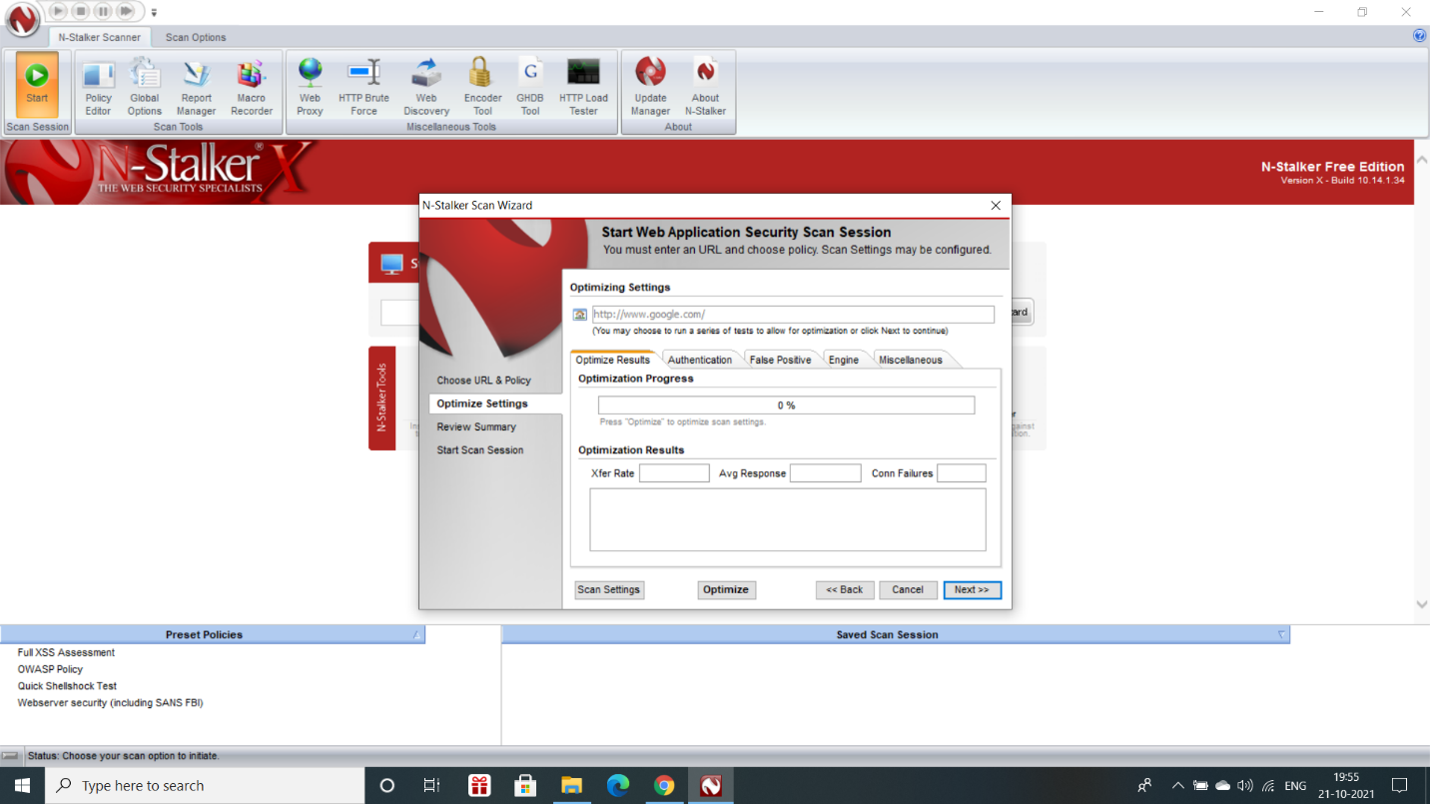

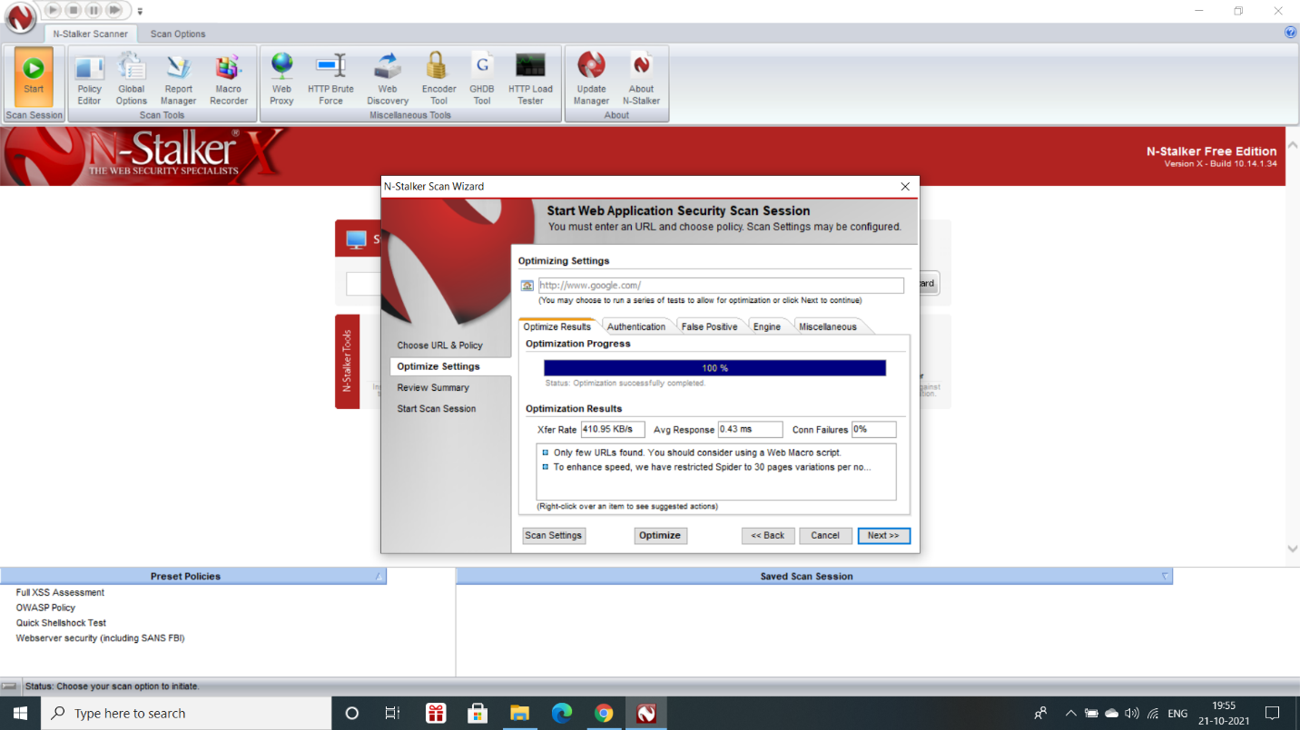

**Step 6:** Click next after optimizing, in review option, you can get all the information like host

information, technologies used, policy name, etc.

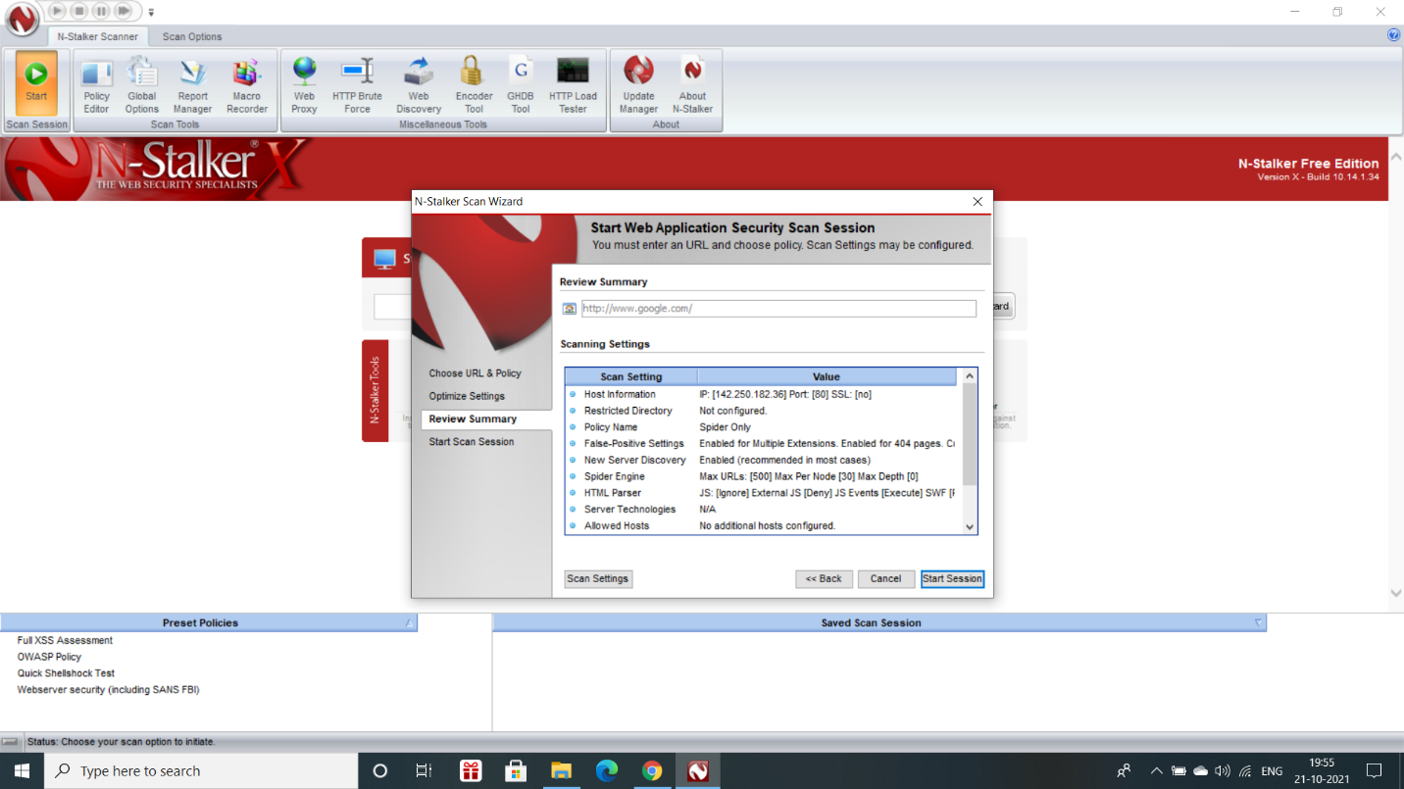

**Step 7:** Once done, start the session and start the scan. The scanner will crawl the whole website and will show the scripts, broken pages, hidden fields, information leakage, web forms related information which helps to analyse further.

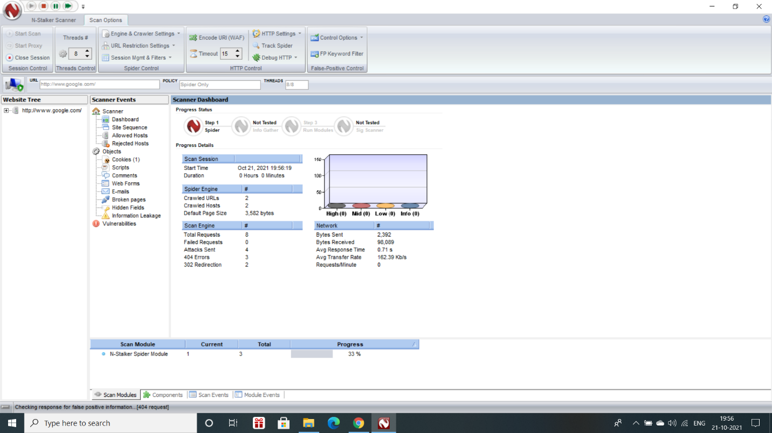

**Step 8:** Once the scan is completed, the N-Stalker scanner will show details like severity level,

vulnerability class, why is it an issue, the fix for the issue and the URL which is vulnerable

to the vulnerability.

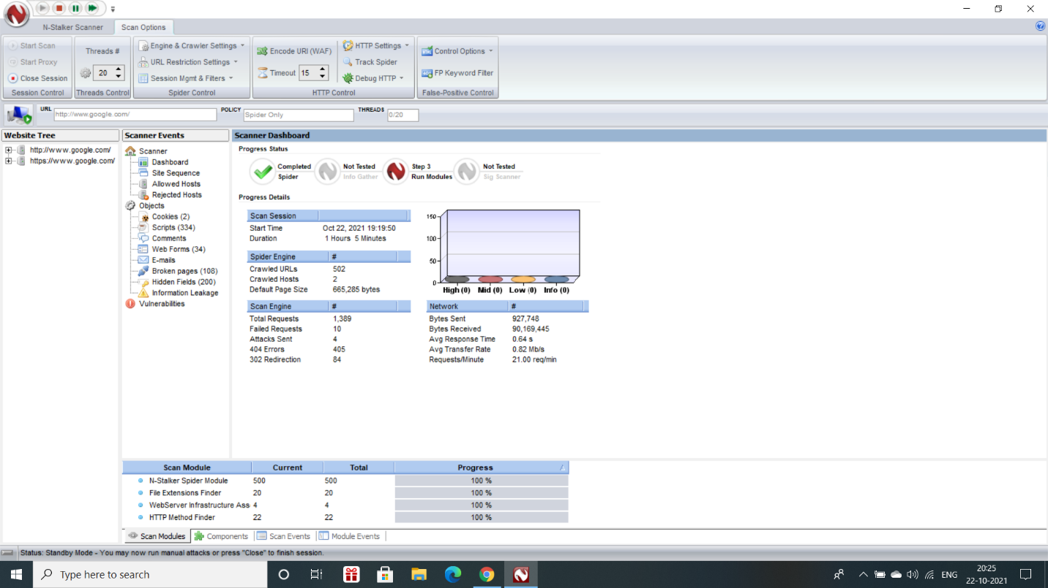

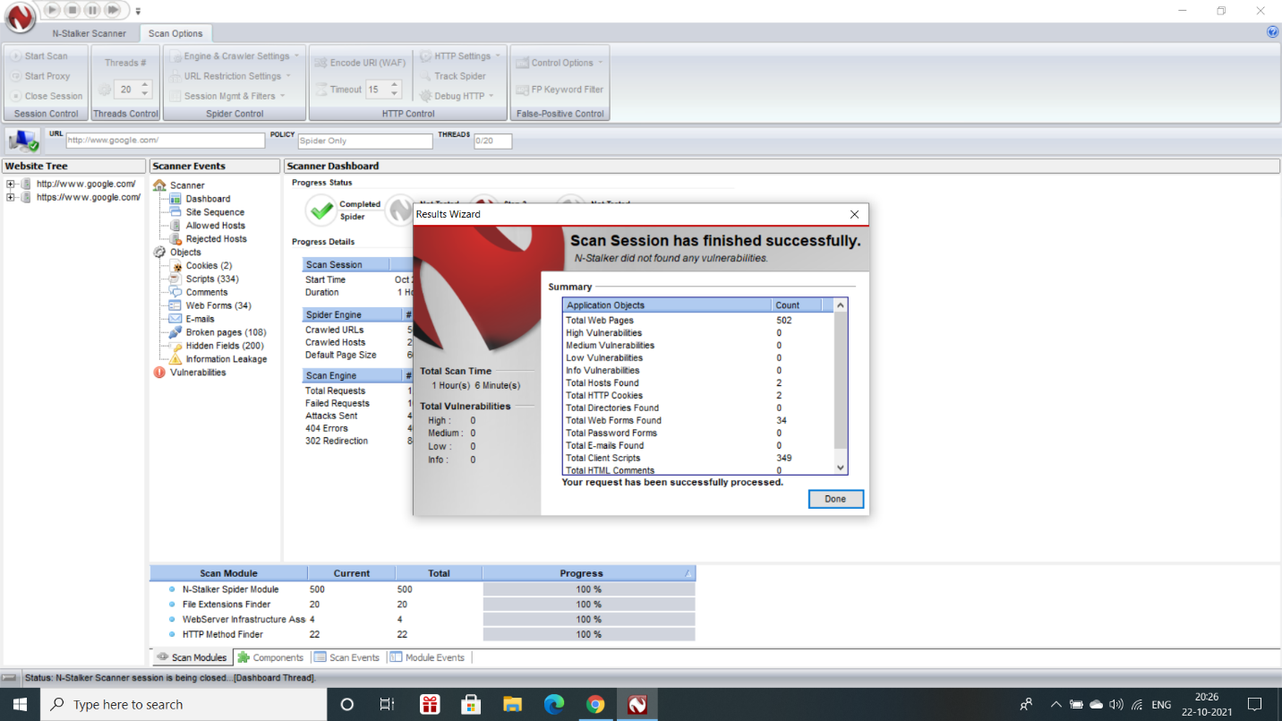

**RESULT:**

Thus, the N-Stalker Vulnerability Assessment tool has been downloaded, installed and the features have been explored by using a vulnerable website.

**EXPERIMENT NO.:11–DEFEATING MALWARE**

**BUILDING TROJANS**

**AIM:**

To build a trojan and know the harness of the trojan malwares in a computer system.

**THEORY:**

* Trojans are programs that pretend to do one thing but, when loaded, perform another, more malicious act.
* Before a Trojan program can act, it must trick the user into downloading it or performing some type of action. For example, a user is duped into executing an email attachment disguised to appear not suspicious, (e.g., a routine form to be filled in), or by clicking on some fake advertisement on social media or anywhere else.
* Trojans may allow an attacker to access users’ personal information such as banking information, passwords, or personal identity. Example: Ransomware attacks are often carried out using a trojan.
* Unlike a virus or worm, Trojans cannot spread themselves. They rely on the uninformed user. Examples of Trojans are: Net Bus, Sub Seven.
* A way for the security professional to learn about such tools is to install and run one.
* The Task Manager before and after installation, will show some additional services will be loaded into memory.
* These tools will set off the antivirus software, so it’s advisable to install and run them on a virtual machine. This allows more control and the ability to restore the virtual machine to a previous snapshot after completing your research.

**ALGORITHM:**

**Step 1:**Create a simple trojan by using Windows Batch File (.bat).

**Step 2:**Type the code in notepad and save it as Trojan.bat.

**Step 3:**Double click on Trojan.bat file.

**Step 4:**When the trojan code executes, it will open the Command Prompt infinitely and so is called as infinite pop-up effect.

**Step 5:**Restart the computer to stop the execution of this trojan.

**SOURCE CODE:**

**@echo off**

**:x**

**start cmd**

**goto x**

**OUTPUT SCREENSHOT:**

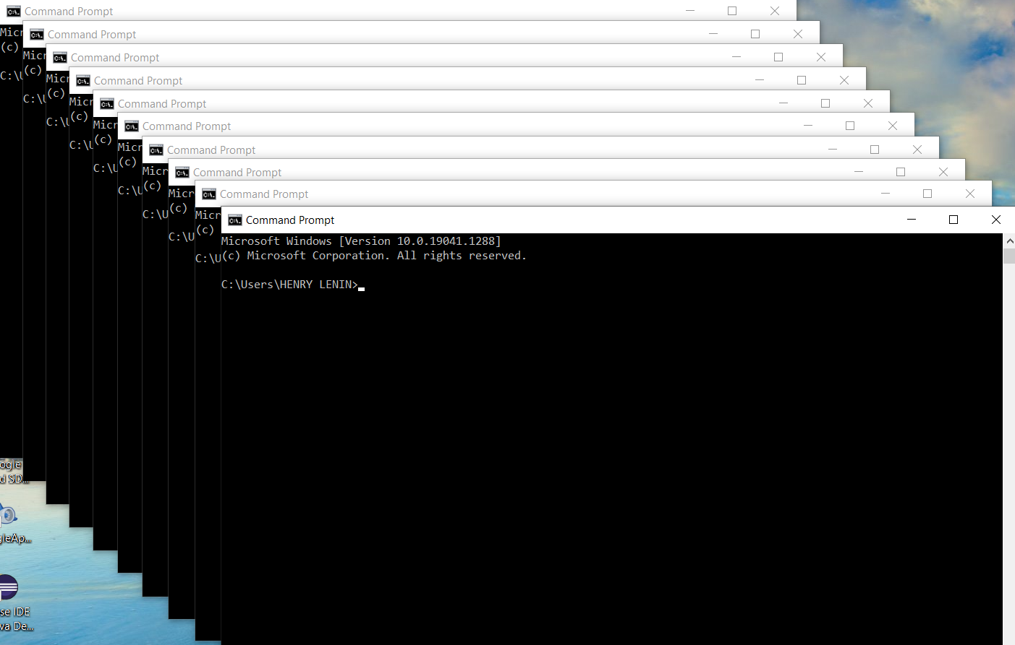

**RESULT:**

Thus, a trojan has been built and the harness of the trojan viruses has been explored.

**EXPERIMENT NO.:12 ROOTKIT HUNTER**

**AIM:**

To install a Rootkit Hunter and find the malwares in a computer.

**THEORY:**

* Rootkit Hunter (rkhunter) is a Unix-based tool that scans file and system binaries for rootkits, backdoors, and possible local exploits.
* It compares the SHA-1 hashes of important files with known good ones in online databases, searching for default directories (of rootkits), wrong permissions, hidden files, suspicious strings in kernel modules, and special tests for Linux and FreeBSD.
* The tool has been written in Bourne shell, to allow portability. It can run on almost all UNIX-derived systems.
* GMER is a software tool written for detecting and removing rootkits.
* It runs on Microsoft Windows and has support for Windows NT, 2000, XP, Vista, 7, 8 and 10.After downloading the tool, run it from a Windows system and let it scan the system.
* If anything is found, remove it. Restoring from a backup is not a good option, as you may have no idea how long the rootkit has been installed. It is best to reload from known good media.

**DOWNLOADING GMER ROOTKIT TOOL:**

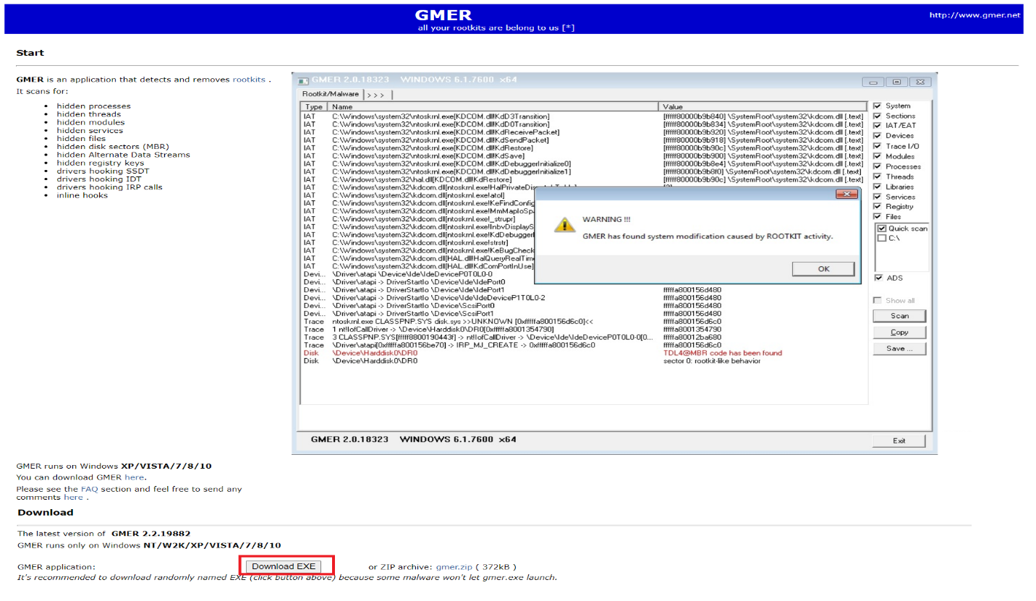

**RUNNING GMER TOOL:**

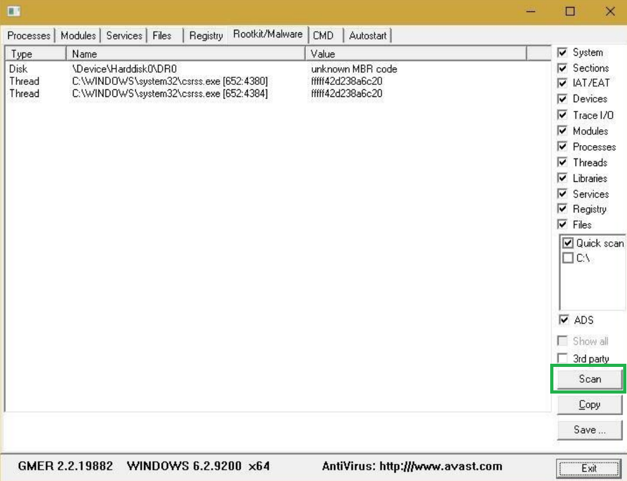

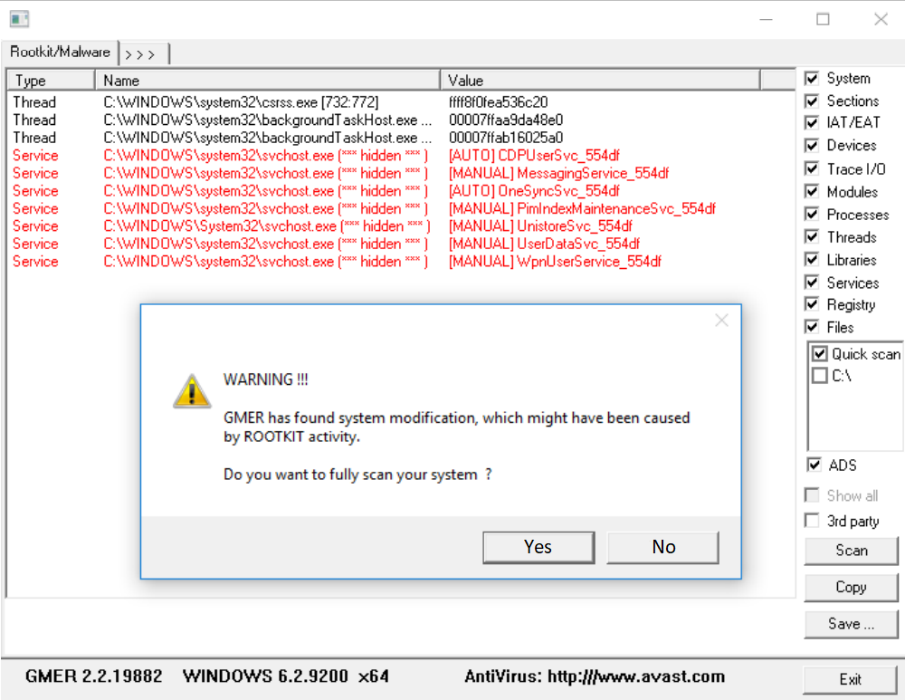

**RESULT:**

Thus, Rootkit Hunter software tool has been installed and the rootkits have been detected.

**CONTENT BEYOND SYLLABUS**

**EXPERIMENT NO.:13 WIRELESS AUDIT – NET STUMBLER**

**Aim:**

To perform a wireless audit on an access point or a router and decrypt WEP and WPA using NetStumbler tool.

**Description:**

Wireless security is the prevention of unauthorized access or damage to computers using [wireless](http://en.wikipedia.org/wiki/Wireless) networks. The most common types of wireless security are [Wired Equivalent Privacy](http://en.wikipedia.org/wiki/Wired_Equivalent_Privacy) (WEP) and [Wi-Fi Protected Access](http://en.wikipedia.org/wiki/Wi-Fi_Protected_Access) (WPA). WEP is a notoriously weak security standard. The password it uses can often be cracked in a few minutes with a basic laptop computer and widely available software tools. WEP is an old IEEE 802.11 standard from 1999 which was outdated in 2003 by WPA or Wi-Fi Protected Access. WPA was a quick alternative to improve security over WEP. The current standard is WPA2; some hardware cannot support WPA2 without firmware upgrade or replacement. WPA2 uses an encryption device which encrypts the network with a 256 bit key; the longer key length improves security over WEP.

**NetStumbler tool:**

NetStumbler (also known as Network Stumbler) is a tool for [Windows](http://en.wikipedia.org/wiki/Microsoft_Windows) that facilitates detection of [Wireless LANs](http://en.wikipedia.org/wiki/Wireless_LAN) using the 802.11b, 802.11a and 802.11g WLAN [standards](http://en.wikipedia.org/wiki/IEEE_802.11). It runs on Microsoft Windows operating systems from Windows 2000 to Windows XP. A trimmed-down version called MiniStumbler is available for the handheld [Windows CE](http://en.wikipedia.org/wiki/Windows_CE) operating system.

NetStumbler delivers a tool that helps you detect 802.11 a/b/g WLAN standards. While wardriving is its main use, the application also facilitates the verifying of network configurations. You can easily find locations that suffer from weak signal within a WLAN, detect issues of wireless interference and rogue access points. Thus, you are able to aim directional antennas in order to benefit from extended wireless signal quality and strength

NetStumbler (Network Stumbler) is one of the Wi-Fi hacking tool which only compatible with windows, this tool also a freeware. With this program, we can search for wireless network which open and infiltrate the network. Its having some compatibility and network adapter issues.

The GUI of the program draws a simple window along with its menu and button bar as well as two panels for browsing features and statistics of found wireless LANs. You are able to sort them by their Channel or SSID and also apply filters such as Encryption, ESS (Extended Service Set), IBSS (Independent Basic Service Set), CF Pollable, Short Preamble, PBCC (Packet Binary Convolutional Code) or Short Slot Time.

NetStumbler also delivers detailed information about detected networks and their correspondent routers and access points. You are given the MAC address, SSID, Name, Channel, Speed, Vendor, Type, Encryption, SNR (Signal-to-Noise Ratio), Signal, Noise, IP address, Subnet, Latitude, Longitude or First / Last Seen. The application also supports GPS modules for the wardriver in you.

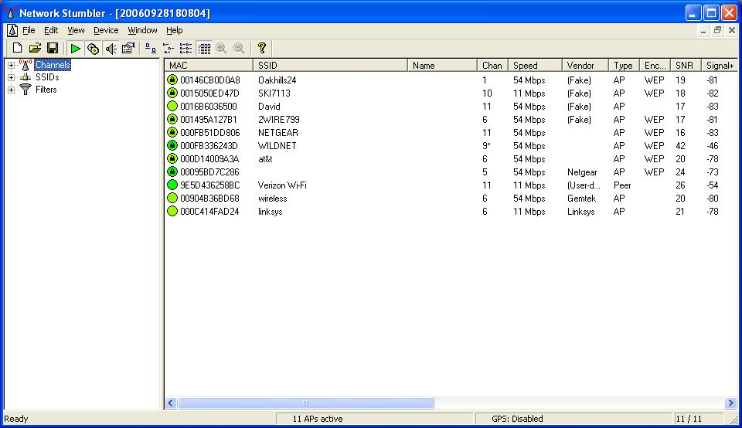

The first thing we notice is a window with a bunch of green bubbles. The green means that the signal is strong. Other colors include yellow which indicates a weaker signal, red for a very weak signal and grey for signal loss.

We will also see that some APs have lock symbols in the green bubble and others don't. The lock symbol is the first indication that the AP has encryption enabled. Along the same column we'll notice the header or title of that column is MAC. The Media Access Control or MAC address is a unique code assigned to networking hardware, in this case the MAC address is referring to the address assigned to the Wireless AP (WAP). So beside the green bubble we will see the 12 character MAC address for that AP.

The next column displays that APs Service Set Identifier (SSID). The SSID is basically the name of the AP and must be known to join. If our network is a closed network for home use only then we don't want to broadcast the SSID. This is one of the APs configuration options. As we can see 10 of the 11 APs are broadcasting their SSID. As far as securing your network, choosing not to broadcast your SSID wont make or break you. It just makes it a little more difficult to crack.  
  
The SSID column can be very useful to crackers because, they will look for an easy network to crack. If someone was looking for a target network, then they would immediately hone in on the AP with the SSID linksys. The SSID linksys is the Linksys routers default SSID. We also notice that encryption has not been enabled. At this point we could attempt to get into the APs configuration page by joining the network and typing 192.168.1.1 in the web browser. Next, we will be asked for a user name and password. Since everything else is set to the default settings, we can try the Linksys default username and password. The default user name and passwords are easily found for most routers on the internet on pages such as (<http://www.phenoelit.de/dpl/dpl.html>). As we can see it helps to know which version of the Linksys router is deployed. One thing we can do is look at the Speed column. we can see that this Linksys router is running at 11Mbps. This tells that it is NOT an 802.11G router, which eliminates some of options. So we would try leaving the username and password blank then entering or leaving the username blank and typing admin for the password.

Obviously, just by joining the network a cracker can do a lot of damage, but obtaining access to the AP configuration tool makes things so much easier. First they can go to the logs and obtain your personal computers MAC addresses, which can later be used maliciously with a MAC spoofing tool. They can play a prank on you and block your computers MAC addresses from joining your own network. Now of course this is easily solved by rebooting the router, but if you don't understand your wireless router it might be enough to make you very frustrated and maybe even throw your router away.

Finally, let's take a look at those APs that do have encryption enabled. One of the flaws with the latest version of NetStumbler is that all enabled encryption is displayed as WEP. This makes cracking a little more difficult, because a cracker wouldn't know whether to perform a WEP crack or a try a brute-force attack on WPA. Once again this is another reason why we always say something is better then nothing. If you have WEP use it, if you have WPA (which is downloadable for most older routers) use it. I would need to spend a lot less time cracking the linksys AP then the Netgear AP and thus the linksys AP would be the first choice.

**Procedure:**

* It is highly recommended that your PC should have wireless network card in order to access wireless router.
* Now Run Netstumbler in record mode and configure wireless card.
* There are several indicators regarding the strength of the signal, such as GREEN indicates Strong, YELLOW and other color indicates a weaker signal, RED indicates a very weak and GREY indicates a signal loss.
* Lock symbol with GREEN bubble indicates the Access point has encryption enabled.
* MAC assigned to Wireless Access Point is displayed on right hand pane.
* The next coloumn displays the Access points Service Set Identifier[SSID] which is useful to crack the password.
* To decrypt use WireShark tool by selecting Edit→preferences→IEEE 802.11
* Enter the WEP keys as a string of hexadecimal numbers as A1B2C3D4E5

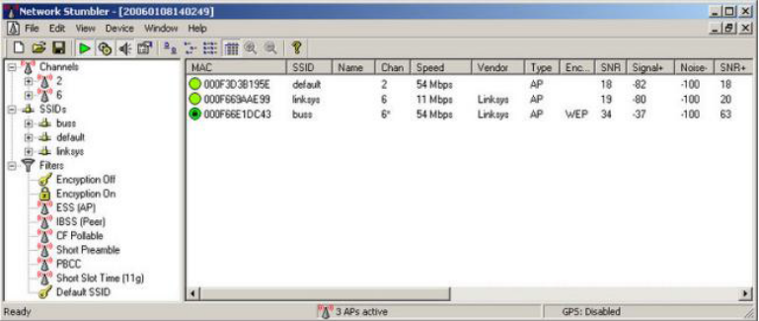

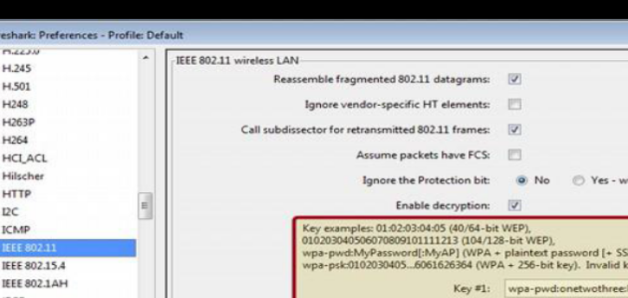

**Adding Keys**: Wireless Toolbar

If you are using the Windows version of Wireshark and you have an AirPcap adapter you can add decryption keys using the wireless toolbar. If the toolbar isn't visible, you can show it by selecting View->Wireless Toolbar. Click on the Decryption Keys... button on the toolbar:

This will open the decryption key managment window. As shown in the window you can select between three decryption modes: None, Wireshark, and Driver:

**EXPERIMENT NO.:14**

**HONEY POT - (KF SENSOR)**

**Aim:**

To setup a honey pot and monitor the honey pot on network (KF Sensor).

**Description:**

KFSensor is windows based Honeypot IDS (Intrusion Detection System), which acts as a honeypot to attract and detect hackers or other unauthorized users and Trojans by creating a virtual vulnerable system and services.

By acting as a lure server or system it can divert all attacks and unauthorized visiting from a crucial and critical system. KFSensor is designed to use in windows based corporate level company and provides a cost effective way to improve network level security.

**What is the use of KFSensor?**

KFSensor detects unknown threats and improves security, whilst also providing a low maintenance and cost effective solution.

**Honey pot technology:**

Honey pots have low false positives and easily complement other existing forms of security that may be in place.

**Built for Windows:**

Designed for use in a Windows based corporate network, it is easy to both deploy and maintain.

**What KFSensor does?**

**Monitors all traffic:**

* KFSensor acts as a honey pot, designed to attract and detect hackers and worms by simulating vulnerable system services and trojans.
* KFSensor is pre-configured to monitor all TCP and UDP ports, along with ICMP. It is also configured with the emulation of common services.
* It starts monitoring right after its installation and can be easily customized to add additional customer services later on.

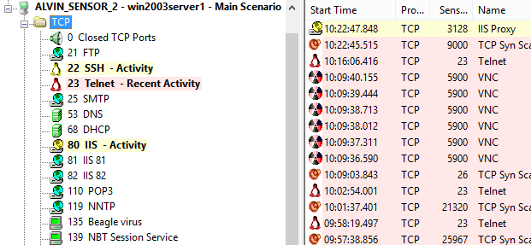

**Interacts with an attacker:**

By responding with an emulation of a real service KFSensor is able to reveal the nature of an attack whilst maintaining total control of the incident and avoiding the risk of compromise.

As well as individual service attacks KFSensor detects and responds to port scans and denial of service DOS attacks and prevents itself from being overloaded.

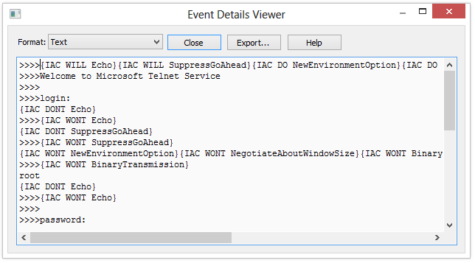

**Alerts:**

KFSensor can send real time alerts by email or via integration with a SEIM system. The KFSensor administration console allows events to be filtered and examined in detail, allowing comprehensive analysis of any attack. KFSensor also makes a full packet dump available for additional analysis, using tools such as Wireshark.

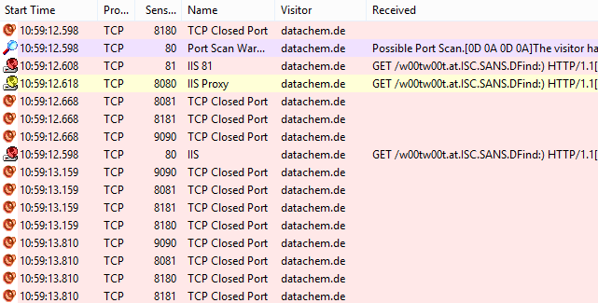

**Statistical Analysis:**

The KFSensor Reports module provides a range of reports and graphs that can be used analyse many different aspects of the attacks facing an organization. The reports are particularly useful in highlighting patterns of attacks the are only identifiable over time. All reports can be filtered on time period, attack type and the location of the visitors, allowing for detailed study and analysis of a particular threat.

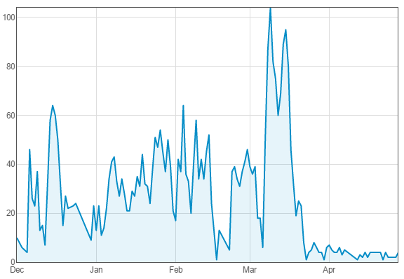

**Procedure:**

**Step1- Install KFSensor:**

Let's open a browser and navigate to www.kfsensor.com, then download and install the software. It's a 30-day trial version. Once it is installed, right-click on the KFSensor icon and "run as administrator".

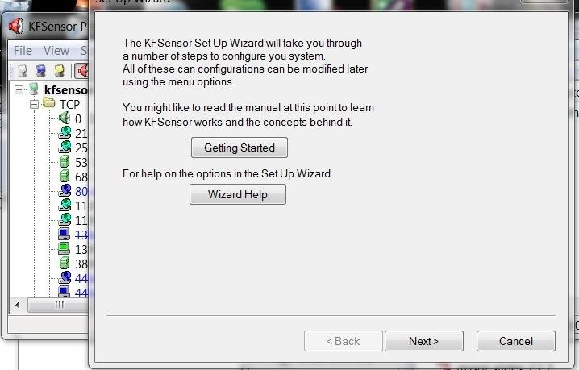

After going through a few more screens in the wizard choosing the defaults, we come to the screen below that allows you to choose the native services. Let's choose all of them.

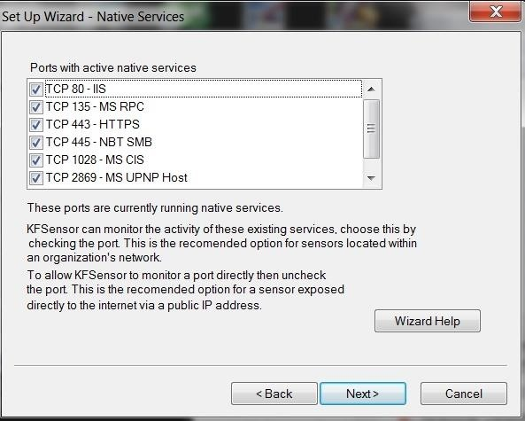

Then, choose the domain name. The default is networksforu.com. Next, we can choose an email address where we want to send the alerts.

**Step 2-Choose Options:**

Finally, we have a few options to choose. Let's go with the defaults, but note the final option. Here it allows us to capture the packets so that we can analyze the attacks with a tool like Wireshark or any other protocol analyzer.

It gives a warning, that packet captures can take up a lot of disk space; if you're trying to catch or study a hacker, it's necessary. We'll leave it disabled for now.

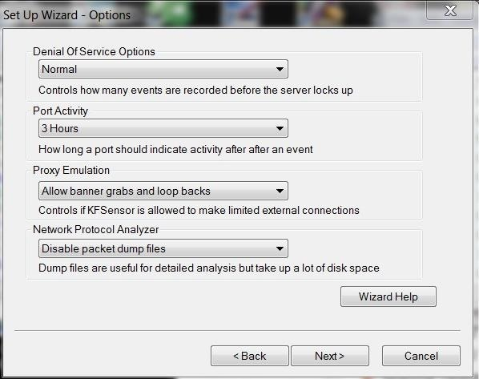

**Step 3-Set Up Your Honeypot and Watch:**

When we have completed the wizard, click Finish and now we should have an application which looks like this.

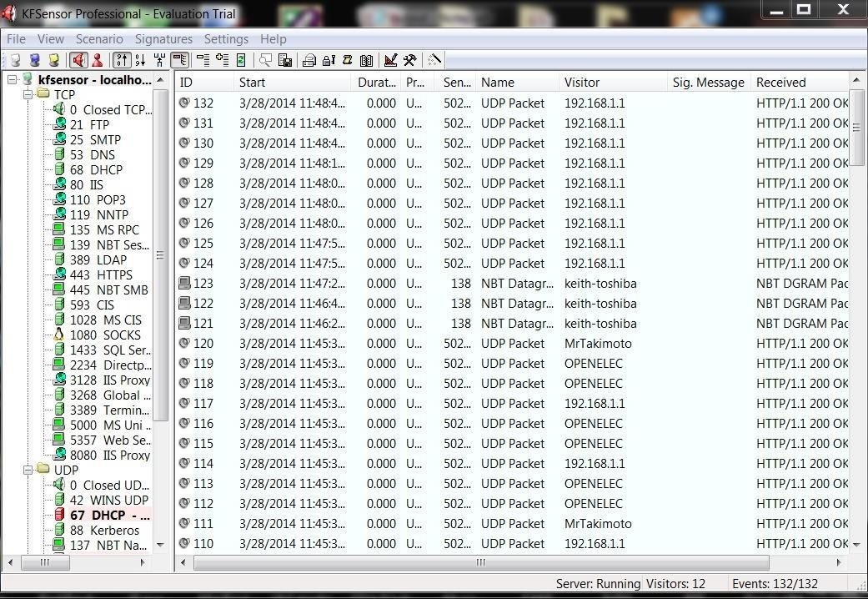

**Step 4-Sacn with Nmap:**

Now that we have our honeypot setup, let's take the approach of the hacker. Just as if we were doing recon on a potential target, let's use nmap to scan that system. Let's do a SYN scan:

• nmap -sS 192.168.1.102

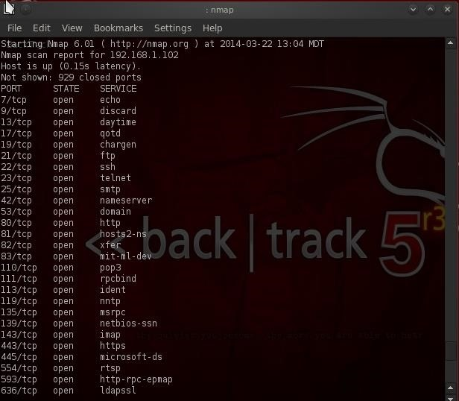

As we can see, we find numerous ports open. As a hacker, this is a big RED FLAG. If we go back to the honeypot, we can see that we set off an alert for a port scan in the purple highlighted area.

Remember that a SYN scan does not complete a 3-way handshake, but most intrusion detection systems consider many packets coming in rapid succession from one IP to be a "possible port scan". This is one reason why it is often advisable to slow your scan down with nmap's built-in speed controls.

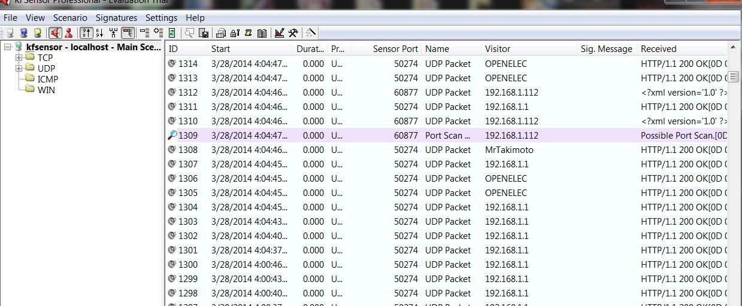

**Step 5-Scan with Nikto:**

Let's scan with Nikito,

• ./nikto.pl -h 192.168.1.102

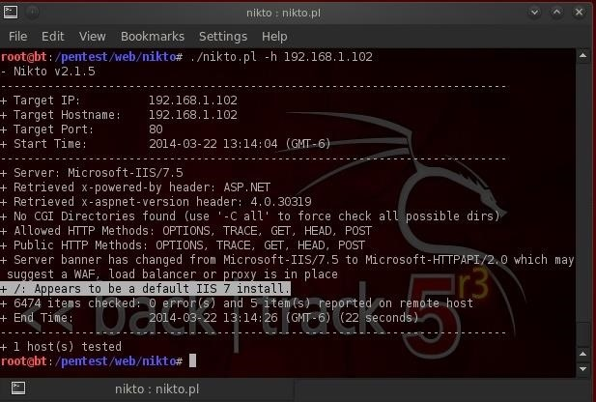

Our results tell us that this system is a default install of Microsoft's IIS 7 server. Another RED FLAG that this might be a honeypot.

**Step 6-Banner Grab:**

Lastly, let's try a banner grab. We can connect with netcat to port 80 and then try to grab the web server banner, if there is one.

• nc 192.168.1.102 80

• HEAD / HTTP/1.0

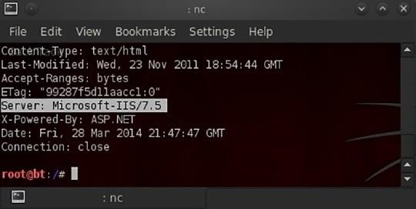

As we can see, we were able to grab the banner identifying the web server as Microsoft's IIS 7.5.

**Using KFSensor:**

The below screen is the main window of KFSensor tool.

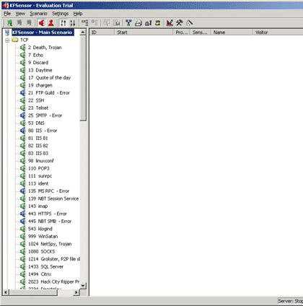

As we can see, the column on the left contains a list of port numbers and what the port is typically used for. If the icon to the left of a port listing is green, it means that KFSensor is actively monitoring that port for attacks. If the icon is blue, it means that there has been an error and KFSensor is not watching for exploits aimed at that particular port.

Once the software up and running, one of the best things that we can do is to test the software by launching a port scan against the machine that's running KFSensor. For the port scan, we can use a shareware utility called HostScan. It simply scans a block of IP addresses, looking for open ports. The below screen shows how the KFSensor reacts to a partial port scan.

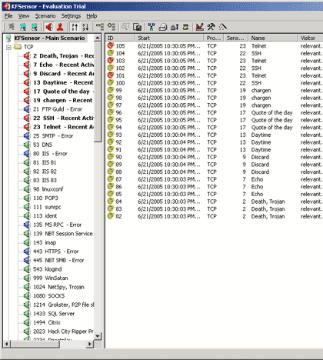

In the screen, we will notice that the icons next to ports that were scanned turn red to indicate recent activity. We will notice that there is a summary of all of the detected activity in the column to the right.

The icon next to each entry is color coded either red or yellow according to the severity of the event. We can also click on any of the individual ports, and the column on the right will display only events related to that specific port. We can then double click on an event to gain more detailed information about it. For example, we can determine the event's start and end time, the IP address of the machine that the activity is coming from, and even the domain that the attacking machine belongs to.

**Step 7 - Building an activity log:**

OK, so we've proven that the honeypot can detect activity, and we've even logged some activity. That's great for short term testing, but in a real life situation, we would probably want to log activity to a database. Having such a record is important in case we need to do some in depth forensics or in case we need to get law enforcement involved after a security breach.

KFSensor does log activity by default, but it uses a text file rather than a database. The reason why it's important to use a database is because a database generally has a higher capacity and makes it easier to search for what we need than a text file does. Furthermore, if a hacker were to figure out that we were running KFSensor, and they were able to gain control over the system, then they could easily erase the log file to cover their tracks.

The database of choice for KFSensor is SQL. Simply create a SQL database in the usual manner. After doing so, select the Log Database command from the KFSensor console's Settings, we will see the dialog box shown below. Simply fill in the blanks to connect KFSensor to the database that we have created.

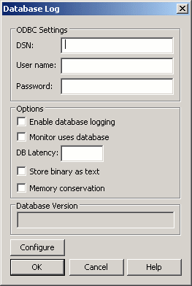

| The Database Log dialog box allows you to connect KFSensor to a SQL database. |
| --- |

**Step 8- Modifying the honeypot's behavior:**

So far we have deployed a KFSensor based honeypot and logged the data that is collected. Now let us try to change the behavior of honey pot.

Like most honeypots, KFSensor is rules based. All of the data that was produced was the result of KFSensor detecting certain types of activity and then using a rule to determine what type of action should be taken. The nice thing about KFSensor is that we can easily modify the existing rules or add our own rules.

To create or modify rules, select the Edit Active Scenario command from the Scenario menu. We can either select a rule or click the Edit button to edit a rule, or we can click the Add button to create a new rule. Both procedures work similarly.

Click the Add button and you will see the Add Listen dialog box. The first thing that this dialog box asks for is a name. This is just a name for the rule. Pick something descriptive though, because the name that we enter is what will show up in the logs whenever the rule is triggered.

|  |
| --- |
| http://tr1.cbsistatic.com/hub/i/2015/06/03/104b4d52-098c-11e5-940f-14feb5cc3d2a/5786723-honeypot-d.gif |
| The Add Listen dialog box allows you to create your own rules. |
|  |

The next few fields are protocol, port, and Bind Address. These fields allow you to choose what the rule is listening for. For example, we could configure the rule to listen to TCP port 1023 on IP address 192.168.1.100. The bind address portion of the rule is optional though. If you leave the bind address blank, the rule will listen across all of the machine's NICs.

Now that we have defined the listener, it's time to configure the action that the rule takes when traffic is detected on the specified port. The options are close, read and close, Sim Banner, and Sim Std Server. The close option tells the rule to just terminate the connection. Read and close logs the information and then terminates the connection.

The Sim Std Server and Sim Banner options pertain to server emulation. The Sim Banner option allows us to perform a very simple server emulation, such as what you might use to emulate an FTP server. The Sim STD Server option allows us to emulate a more complex server, such as an IIS server. If we choose to use one of the sim options, we will have to fill in the simulator's name just below the Time Out field.

The other part of the Action section that's worth mentioning is the severity section. The dialog box's Severity drop down list allows us to determine what level of severity should be associated with the event that you are logging.

The final portion of the Add Listen dialog box is the Visitor DOS Attack Limits section. This section allows us to prevent denial of service attacks against KFSensor. We can determine the maximum number of connections to the machine per IP address (remember that this applies on a per rule basis).

If the threshold is exceeded, we can choose to either ignore the excessive connections or we can lock out the offending IP address.

Now that we have configured the new rule, select the Active check box to enable the rule and click OK. The new rule should now be in effect.

**Result:**

Thus a honey pot using KFSensor tool setup is done and the network is monitored successfully.